# 



School of InfoComm Technology

**Data Discovery & Visualisation**

Diploma in Data Science

October 2022 Semester

**ASSIGNMENT 1**

**(Individual Assignment)**

**Submission Deadline:**

**7 December 2022 (Wednesday), 12 Noon**

|  |  |  |
| --- | --- | --- |
| **Student Name** | **:** | Akul Arun |
| **Student Number** | **:** | S10243523 |
| **Video submission link** | **:** | <https://youtu.be/lXQzmwJhaoQ> |

**Penalty for late submission:**

10% of the marks will be deducted every calendar day after the deadline.

**NO** submission will be accepted after 14 December 2022 (Wednesday), 12:00 Noon

Table of Contents

Section 1: Background Information on myself and clients 3

Section 2: Data Preparation 3

2.1 Removing Duplicates 4

2.2 Changing Casing of flat_model values 5

2.3 Calculating Remaining Lease 7

2.4 Combining all files 12

2.5 Standardizing format for 2-Room under flat_model column 12

2.6 Standardizing format of Multi Generation under flat_type column 13

2.7 Creating additional CSV 14

2.7.1 Creating Address.csv 14

2.7.2 Creating region town.csv file 15

2.8 Importing the datasets into Tableau 15

2.8.1 Importing HDB_Resale file 15

2.8.2 Importing Address.csv 16

2.8.3 Importing region town.csv 16

2.9 Downloading Additional Data from the internet 17

2.8.1 Bus Stop dataset 17

2.8.2 Planning area census 2010 spatial file 17

Section 3: Further Research 17

3.1 Calculating Remaining Lease 18

3.2 Understanding Metadata 18

Section 4: Exploratory Questions, Data Visualisations and Dashboards 18

4.1 Client Requirements and Exploratory Questions 18

4.1.1 Client Requirements 18

4.1.2 Exploratory Questions 19

4.2 Visualisations 19

4.2.1 Size of the different flat models of the different flat types 20

4.2.2 Average resale price of flat models 20

4.2.3 Trends in average resale prices through the years 21

4.2.4 Number of flats in budget 21

4.2.5 Average price per square meter for flat models 22

4.2.6 Proportion of number of flats sold in each region 22

4.2.7 Average resale price of flats across different towns 23

4.2.8 Relationship between the story range and average resale price 24

4.2.9 Relationship between the average resale price and the size of the flat 25

4.2.10 Percentage of number of flats sold for each flat type across different regions 26

4.2.11 Distribution of flat prices of flat types in towns 26

4.2.12 Number of flats sold in each street of a town 27

4.2.13 Average price of flat types in the streets of a town 28

4.2.14 Number of bus stops in each town 28

4.2.15 Changes in number of flats sold for each flat type through the years 29

4.2.16 Relationship between remaining lease and average resale price 30

4.2.17 Distance of each town from SGH 30

4.3 Dashboards and Data Story 31

4.3.1 General Information Dashboard 31

4.3.2 Factors of flats affecting resale price 32

4.3.3 Comparison between regions 33

4.3.4 Data Story 34

### Section 1: Background Information on myself and clients

The names of my clients are Mr Tan and Mrs Tan and they are a newly married young couple who are looking to buy their first property as a couple together. Mrs Tan is also pregnant with their first baby. This will be the first house they will be purchasing and they also want it to be the house where their child grows up in. They are also planning to have one more child later on. Mr Tan is a therapist who earns about $9000 monthly salary while Mrs Tan is a housewife. Budget is a concern for the couple and they are not looking to spend too much money. Their budget is $330,000.

### Section 2: Data Preparation

The first step I had to do was to prepare the data for use so that I could start doing the visuals. I thought that I had to look at the dataset, prepare the data and get familiar with the data before deciding on my audience and creating my exploratory questions. This way, I would be able to make a more informed decision about my target audience and create better exploratory questions. I did not know much about data preparation so I decided to do some research and learn more about how I could do data preparation. I decided to watch some ‘YouTube’ videos and read some online articles on data preparation to gather a better understanding of what clean data is and how I could achieve getting clean data. From my research, I found that my data had to accomplish certain requirements to be considered clean and good for use. After looking at the datasets, I concluded that the datasets were not clean and incomplete.

### 2.1 Removing Duplicates

The first thing I decided to do as part of the data-cleaning process was to remove duplicate rows in all my datasets. I wanted to ensure that I got rid of unnecessary values of data before connecting that dataset to tableau so that I would be able to cut down on the time spent for the data to load into tableau. All I had to do was select all the rows in the Excel sheet, search “Remove duplicate” in the search bar at the top, and press the ‘Remove Duplicates’ button.

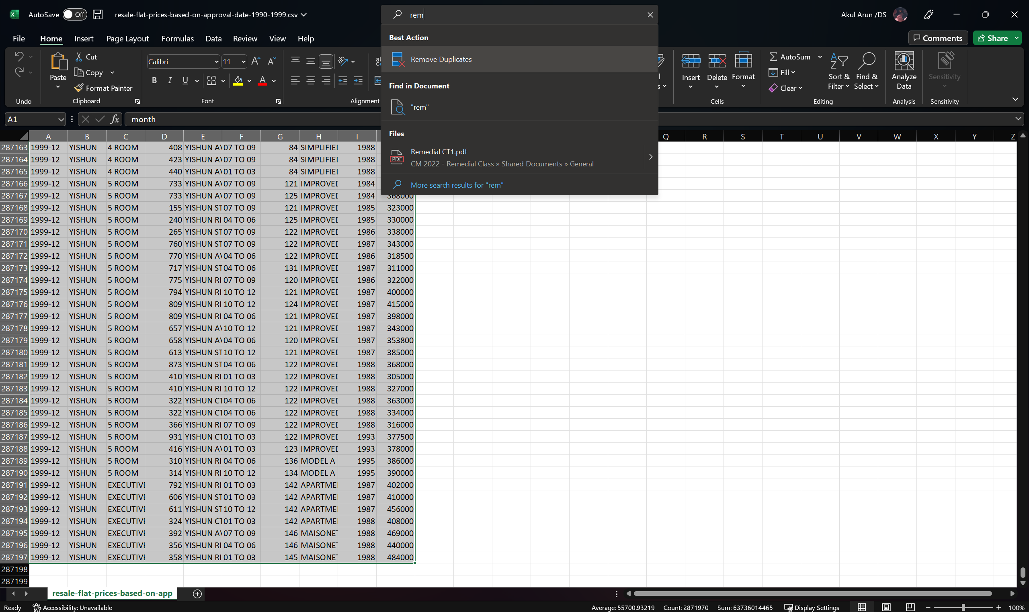

Searching up for the ‘Remove Duplicates’ function in Excel.

1. 1990-1999 approval date file

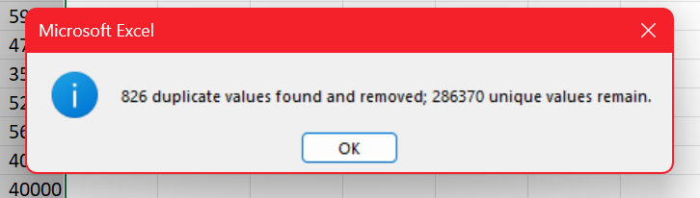

There were 826 duplicate rows in the file which I felt was quite a big number.

1. 2000-2012 approval date file

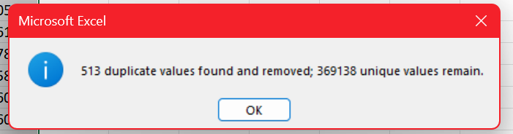

There were 513 duplicate rows in the file.

1. 2012-2014 registration date file

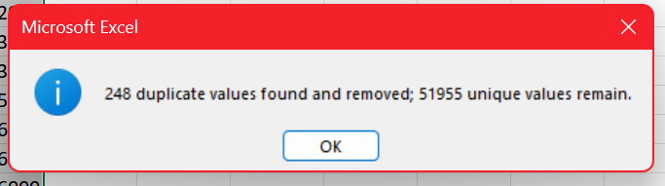

There were 248 duplicate values in the file.

1. 2015-2016 registration date file

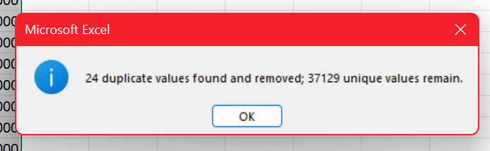

There were 24 duplicate rows in the file that were removed. A small number compared to the number of duplicate rows in the previous files.

1. 2017 onwards registration date file

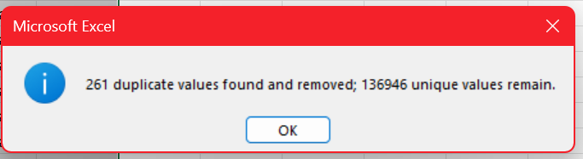

There were 261 duplicate rows in the original file that were removed.

### 2.2 Changing Casing of flat_model values

I had to ensure that the format the data was in was the same in all five of my files. After looking at the casing for all the values in all the columns in all the files, I found that the casing for all the values under the ‘flat_model’ column in the 1990-1999 file was in UPPER casing while the values for the ‘flat_model’ column in the other 4 files were all in the PROPER casing. However, all the values in the other columns in all the files had the same type of casing and had no problems.

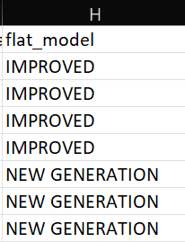

This picture shows the values in the first seven rows under the ‘flat_model’ column in the 1990-1999 file. As seen from the picture, all the values are in UPPER casing.

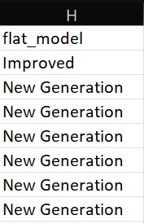

This picture shows the values in the first seven rows under the ‘flat_model’ column in the 2015-2016 file. All these values are in the PROPER casing where only the first character of each string is capitalized. As I said earlier, the values under the ‘flat_model’ column also had the PROPER casing in the remaining files.

I had to ensure that the casing for all the values under the same column in all the files was the same because tableau recognizes ‘IMPROVED’ and ‘Improved’ as two different values even though they are the same so I decided to change the casing of the values in the 1990-1999 file to the PROPER casing.

I got the casing of the first value under the original ‘flat_model’ column by using the PROPER() function. I wanted the new value to be under my new column so I had to click on the empty cell below the new column before writing down the function.

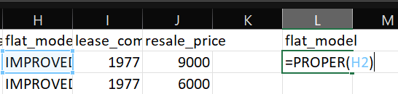

The picture shows how the function looks like in Excel. H2 refers to the cell which contains the value I am reformatting.

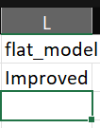

After pressing enter after typing the function, I got the proper format of the original value.

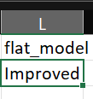

To change the casing of all the values in the original column I just had to double click on the small green square on the bottom right of the cell. By clicking this, Excel will apply the PROPER() function to all the values of the original column and rewrite them in the new casing in the new column.

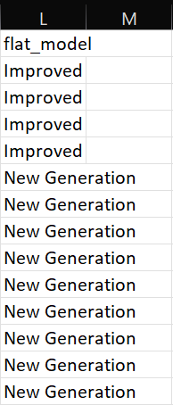

This is the result when I double clicked on the small square.

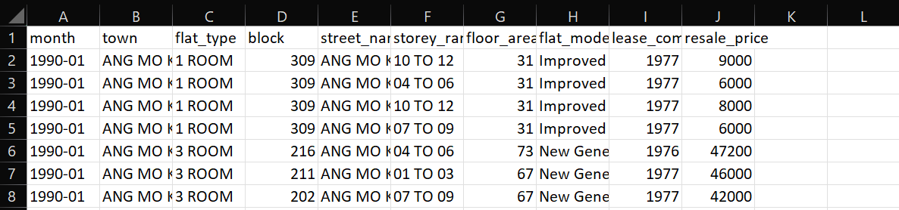

This is how the first 8 columns of how the Excel sheet looked like after doing the above steps. As seen from the values under ‘flat_model’ column, all the values had PROPER casing.

### 2.3 Calculating Remaining Lease

I noticed that some files had the ‘remaining_lease’ column while some did not. From my research, I found that all flats actually have a remaining lease and the formula calculates the remaining lease is

Formula:

Remaining lease(In years)=99 – (the number of years between the year the flat is sold and the lease commencement year)

I will dive deeper and explain more about the reasoning behind this formula in the research section of the report.

I was looking through all my Excel files and I noticed that in the 2017 onwards resale Excel file, some of the values in ‘remaining_lease’ were not numbers and were strings with the number of years and months left in the lease.

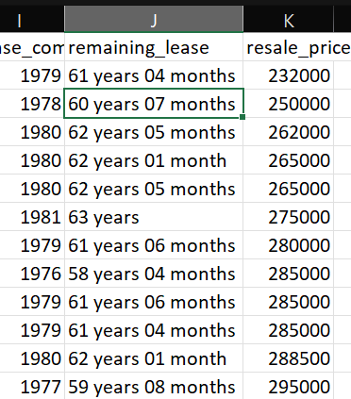

As seen from the picture above, some of the values are strings. Hence, I decided to put all the values for remaining lease as the value for the number of months left in the lease for all the files. I added a new column called ‘remaining_lease_months’ for the value of the number of months left in the lease in all the files.

1. Making remaining_lease_months column for 2017 onwards file

To calculate the values for the ‘remaining_lease_months’ column for the 2017 resale Excel file,I used the ‘Text to Column’ function in Excel.

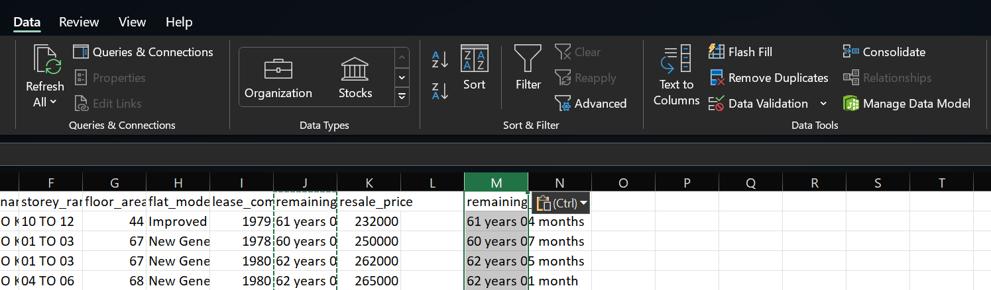

The ‘Text to Column’ button is in the data tools section of the data pane.

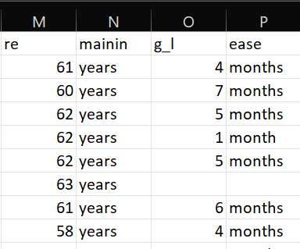

The string for each row got split into 4 columns after using the function. The values in column M represent the number of years while the values in the column O represent the number of months left in the lease.

Then I created a new column called remaining_lease_months. To calculate the total number of months left in the lease, I did (number of years*12) + number of months.

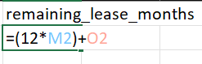

This is what the formula looks like in Excel. M2 is the cell that contains the number of years and O2 is the cell that contains the number of months left in the remaining lease so to calculate the total number of months left in the lease, I had to multiply the number of years by 12 as there are 12 months in each year and then add the remaining number of months. Then I just clicked the small green square at the bottom right of the cell as shown in the picture to fill up the whole column with all the rows of data.

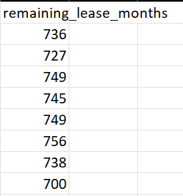

This is what the first few rows of data look like after I double-clicked the small green square.

1. Making remaining_lease_months column for the 2015-2016 file

For this file, all the values for the remaining_lease column were all numbers and they represented the number of years left in the lease. I made a new column called remaining_lease_months in the Excel file. To calculate the number of months left in the lease, I did 12*number of years left which were the values in the remaining_lease column.

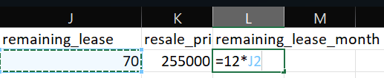

This is how the formula would look in Excel. J2 is the cell that contains the value for the remaining number of years in the lease for the first row of data.

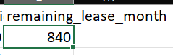

After entering the formula, I just pressed enter and the total number of months in the remaining_lease would appear for the first row of data. To fill up the entire column and all the rows, I just had to double-click on the small green square in the bottom right corner of the cell as shown in the picture.

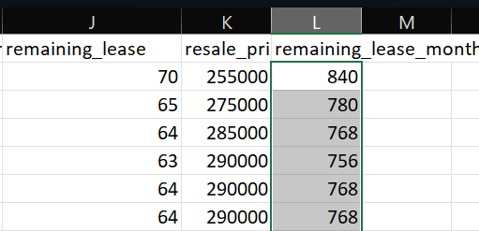

This is how the first few rows of data look like after I double-clicked on the small square.

1. Making remaining_lease_months column for the Excel files that did not come with the remaining_lease column

I decided to make a new column for the remaining lease for all the files that did not have the column. The files that did not have this column from the start were the ‘1990-1999 approval date’ file, the ‘2000-2012 approval date’ file, and the ‘2012-2014 registration date’ file. From the metadata, I found out that the date under the ‘month’ column was the date the flat was sold. Since, I already had the date for when the flat was sold and the lease commencement date, I could calculate the remaining lease for the flats using the formula I introduced just now.

I used the ‘Text To Columns’ function in Excel. I had to use this button because I had to split the values in the month column into year and month as the values in the original month column had values for year and month number separated by a hyphen(-).

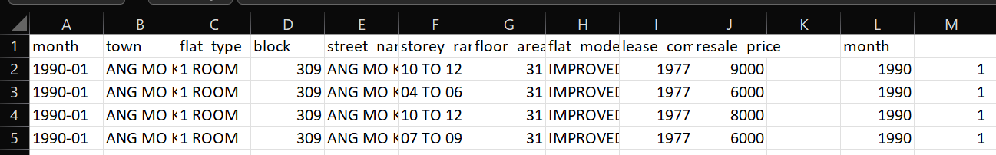

Excel will split the new ‘month’ column to two separate columns. One column with the year value and one column with the month number value.

Now I could create the new column called ‘remaining_lease_month’. To calculate the remaining lease in the years, the formula is:

Formula:

Remaining lease(In years)=99 – (the number of years between the year the flat is sold and the lease commencement year)

Hence, to calculate the remaining lease in months, I just had to take that whole value multiplied by 12 as there are 12 months in a year.

Formula:

Remaining lease(In months) = (99 – (the number of years between the year the flat is sold and the lease commencement year))*12



This is how the formula would look in excel. M2 is the cell that has the year value the flat was sold and I2 is the cell that has the lease commencement year.



After pressing enter, the result is shown above. 1032 represents the number of months in the remaining lease for that particular flat in the first row. In order to fill up the entire row with the values of data, I just had to double-click on the small green square on the bottom right of the highlighted cell.

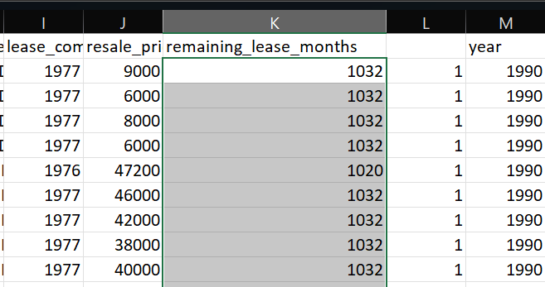

This is the result for the first few rows of data after I double clicked on the small green square.

I did all the steps above for the rest of the Excel files.

### 2.4 Combining all files

I decided to combine all the data in the 5 files into 1 big file because I thought that it would be easier for me to just make one new excel file instead of doing a data union on Tableau. I also thought that it would be faster if I just made one excel file as all I had to do was copy all the data from the five files and put them into the new Excel file.

I made a new Excel file called ‘HDB_resale’. I decided to delete the column for ‘remaining_lease’ from the two files that had this column as I had already created a new column of ‘remaining_lease_months’ for all the files so I did not need ‘remaining_lease’ anymore. I copied all the column heading names from one of the files first and put them into the ‘HDB_resale’ file as all five files had the same column heading names. First, I copied all the values from the 1990-1999 file. Then I pasted all the values into the ‘HDB_resale’ file. I did this a few more times to get all the values from the other files. I did this in the chronological order of the files so that the new file would be more organized.

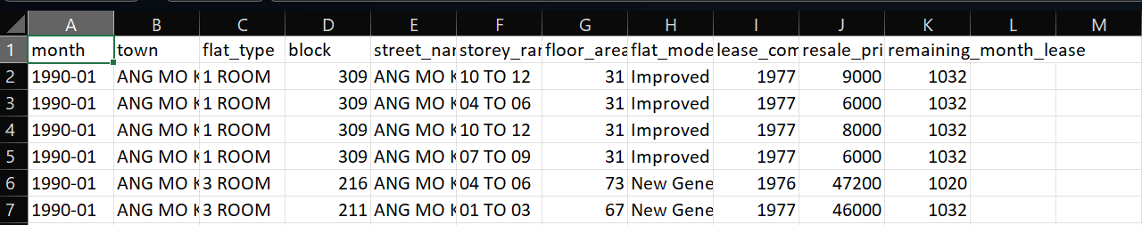

This picture shows the first few rows of the new file.

### 2.5 Standardizing format for 2-Room under flat_model column

After combining all the files into one excel file, I decided to import the excel file into tableau so that I could create visuals and see if there were any problems with my dataset. First, I decided to create a simple bar chart comparing the resale prices across the different flat models.

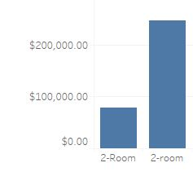

After creating the bar chart, I noticed that there were two columns for 2-Room when there is only supposed to be one bar representing the 2-Room flat model. Hence, I decided to change all the values of ‘2-room’ in my dataset to ‘2-Room’ so that tableau will recognize it as one type of flat model and not two different flat models. I went back to my HDB_resale Excel file and filtered the rows based on ‘2-room’. Since there were very few rows for ‘2-room’, I manually changed the names of all the values in the cell from ‘2-room’ to ‘2-Room’. Then I removed the filter from the Excel file and saved it so that I could reimport the file to Tableau. I created the same bar chart again and I noticed there were some changes.

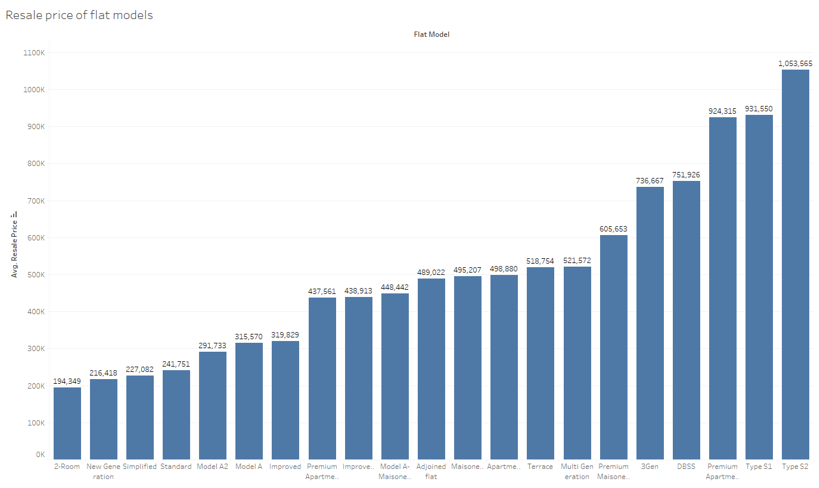

Now, there was only one bar representing the ‘2-Room’ flat model and the bar was also taller as the value of the average resale price of all the 2-Room flats in the dataset was greater.

### 2.6 Standardizing format of Multi Generation under flat_type column

I decided to create a box plot visual that showed the distribution of flat prices in different towns according to the different flat types. However, when I first created the box plot visual, I noticed that there were two box plots for ‘Multi Generation’ flat type.

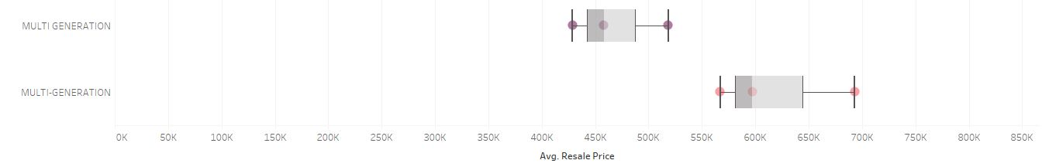

I realized that in the dataset, I had some values for ‘Multi Generation’ that were separated by hyphens while some were separated with a space. I went back to edit my dataset and I decided to remove the hyphens for the values that were separated by hyphens and instead put a space as the separator to standardize the format across all the ‘Multi Generation’ values. I filtered all the values of the ‘flat_type’ column by ‘Multi-Generation’ to show only the rows that had the values ‘Multi-Generation’ under the flat_type column. Since there were very few rows, I decided to manually change all the values to ‘Multi Generation’. After removing the filter and saving the changes, I reimported the ‘HDB_resale’ Excel file into tableau and created the same visual.

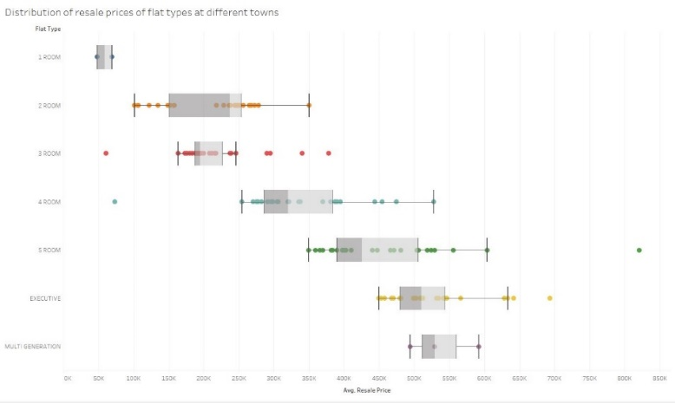

Now, instead of two different columns, there was only one column for ‘Multi Generation’.

### 2.7 Creating additional CSV

### 2.7.1 Creating Address.csv

As I was making my visuals, I realized that I could not make any map visuals as I did not have the longitude and latitude of the different addresses in my dataset. Hence, I decided to make a new Excel file for latitude and longitude. However, there are too many rows of data for the different in my dataset so I could not possibly manually add the values for latitude and longitude into each row and I also did not know the latitude and longitude for each row of addresses. I decided to use OneMap which is the national map of Singapore, developed by the Singapore Land Authority (SLA). I created a new CSV file called Address.csv. In that file, I put in the values for block and street name by copy-pasting it from my hdb_resale file which contained all the addresses. To only have distinct addresses. I used the ‘remove duplicates’ function in Excel. There were 9627 rows of addresses. I also decided to use python to automate the task of adding the latitude and longitudinal values for each row of data of address.

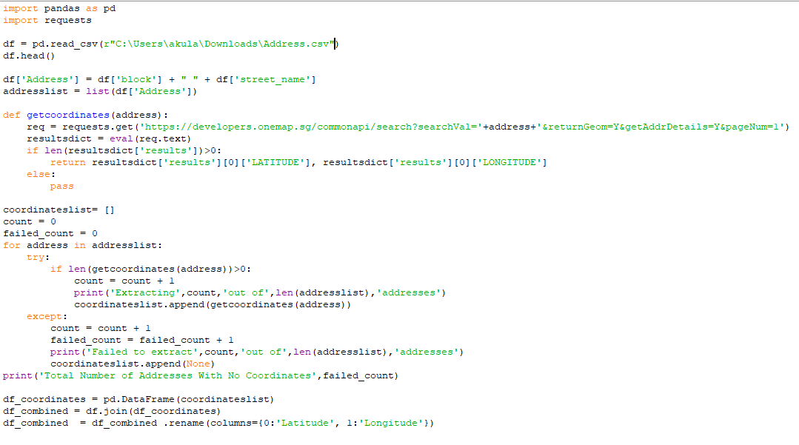

This is the python code I used to add the values to the Excel file. This code is just adding the latitude and longitude column to the Address.csv file and adding the values for the latitude and longitude for each row.

<https://towardsdatascience.com/geocoding-singapore-coordinates-onemap-api-3e1542bf26f7>

After running the program and adding the new columns, I decided to delete the block column as I would not be using it when joining the files in tableau and only needed street name to join the hdb_resale file and the Address.csv file together. It would also be faster to import the file as there are less values.

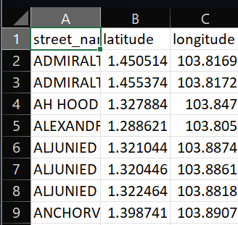

This is how the first few rows of Address.csv file look like.

### 2.7.2 Creating region town.csv file

I wanted to have visuals for the region but the original dataset did not have any values for region. Hence, I decided to make a new CSV file which had two rows, town and region. From the HDB_Resale file I copied the town column and pasted it into the new CSV file. Then I removed the duplicate values so that I was left 28 rows with the unique values of the town names. Next, I looked at the map of Singapore and manually filled up the region values for each of the rows of towns.

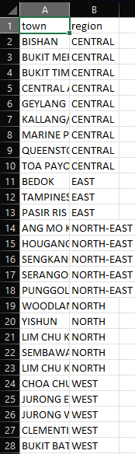

This is how the 28 rows of data in the file looks like.

### 2.8 Importing the datasets into Tableau

### 2.8.1 Importing HDB_Resale file

After opening Tableau, I went ahead and chose to connect to a text file as my HDB_Resale dataset was a CSV file.

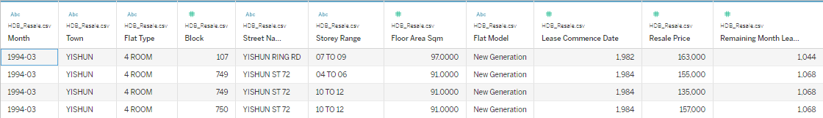

This was how the first few rows of data looked like in the data preview panel in Tableau after importing the HDB_Resale.csv. All the values of data were present in tableau but there were a few problems. Some of the datatypes of some columns were wrong. Month was supposed to be a date data type instead of string, block was supposed to be a string data type instead of a number data type as some blocks have letters in them and lease commencement date was supposed to be a date data type instead of a number data type. I also decided to change the geographic role of the towns column to state/province.

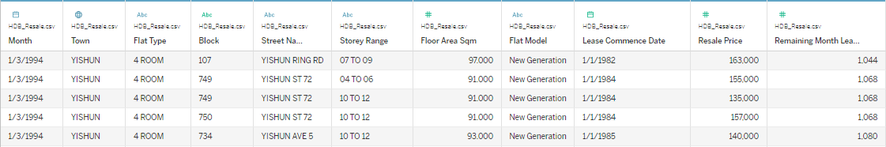

This is how the data preview looked like after I changed the data types that I mentioned earlier. Now, the symbol over some of the columns have changed and the format of the values of some columns have changed.

### 2.8.2 Importing Address.csv

Next, I imported the Address.csv file which had the latitudes and longitudes of the different streets. Then I decided to join both the datasets by joining both the files in the logical layer.

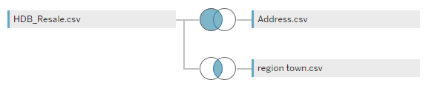

This was how I joined both the files in the logical layer. I used Street Name as the join clause as that was the common column in both the files. I used the left join as I needed all the columns from the HDB_Resale.csv file while I only needed the rows from Address.csv that matched the rows of the HDB_Resale.csv file.

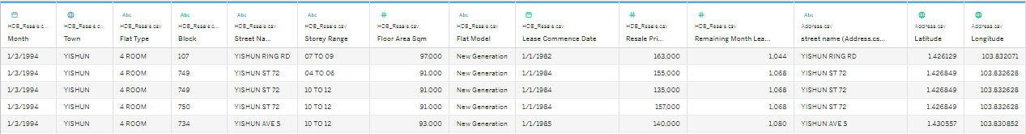

This is how the data preview for HDB_Resale file looks like after I joined the datasets. As seen from the picture, now there are three added columns and these columns are the columns that are in the Address.csv file.

### 2.8.3 Importing region town.csv

Like with the address.csv file, I imported the file and joined it to the HDB_Resale data source in the logical layer.

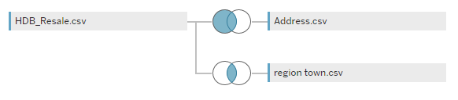

This is how the logical layer of the HDB_Resale data source looked like after joining the file. For the join clause, I used the town field of both the files as that is the only common field between the two files and I used the inner join.

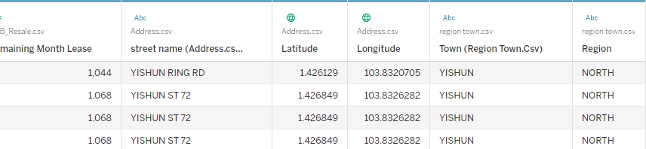

After that, there were 2 added fields as seen from the data preview and these two fields are the columns of the region town.csv file.

### 2.9 Downloading Additional Data from the internet

I needed some extra datasets because the existing datasets that I had did not have some information I needed.

### 2.8.1 Bus Stop dataset

I wanted a dataset that contained the locations of different bus stops. After searching online for a while, I found a CSV file for bus stops that someone had made using python and OneMap API.

<https://github.com/mylee16/onemap-api/blob/master/busstops_with_planning_area.csv>

### 2.8.2 Planning area census 2010 spatial file

I needed this file because in the bus stop dataset, there was central area town name like the HDB_Resale, Address and region town data files and the towns in the bus stop dat file was broken into smaller towns so I had to find another data file that had the same values for town and the region of the towns as I wanted to make a visual that needed the information of bus stops and the region also. Then, I found a spatial file in data.gov.sg that had both the town and region. To confirm that it had the town values I was looking for, I opened it in Tableau by using the connect to spatial file option and found that the values for town were the same.

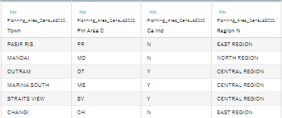

There are a few columns in the file but the columns that I was interested in was only the town column and the ‘Region N’. I renamed the column name for the region from ‘Region N’ to just region for simpler understanding.

<https://data.gov.sg/dataset/planning-area-census2010>

### Section 3: Further Research

To gain a better understanding of the datasets, I performed some extra research.

### 3.1 Calculating Remaining Lease

The first research I did was to find out what the remaining lease was and how the remaining lease was calculated. For this, I just asked my father because he recently bought a new HDB flat, and he had already done his research about HDB flats so I felt he would know about the remaining lease. He told me that all HDB flats have a 99-year lease at the start and the remaining lease is the amount of time the flat belongs to the owner. After the remaining lease ends, the ownership of the flat will be returned to the state and the rights of the property owners are effectively extinguished. There is a formula to calculate the remaining lease which I have already mentioned in part 2.3 of the report.

### 3.2 Understanding Metadata

Next, I studied the metadata to gain a better understanding of what the values in the different columns represent before I created my visuals.

From the metadata, I understood that:

1) The values in the month column represent the month and year the flat was sold.

2) The values in the resale price column represent the price the flat was sold at.

3) The lease commencement year is when the 99-year lease started.

4) The approximate floor area includes any recess area purchased, space adding

item under HDB’s upgrading programs, roof terrace, etc.

5) Resale prices should be taken as indicative only as the resale prices

agreed between buyers and sellers are dependent on many factors.

6) The transactions exclude resale transactions that may not reflect the

full market price such as resale between relatives and resale of part shares.

### Section 4: Exploratory Questions, Data Visualisations and Dashboards

### 4.1 Client Requirements and Exploratory Questions

### 4.1.1 Client Requirements

Like most property buyers, my clients had some requirements too. First of all, they wanted a big HDB flat as they were about to have a baby and they also wanted to have one more child later on, so they were interested in the bigger-sized HDB flats. Their budget was also $330,000 and they did not want to exceed their budget. Like everyone, money is a concern for them. Mr Tan works at the Singapore General Hospital so they wanted to get a house that is close to the hospital. The parents of Mr Tan live in Jurong East which is in the Western region of Singapore while the parents of Mrs Tan live in Bedok, which is in the Eastern region of Singapore, so they were unsure of getting a house in the Eastern region or in the Western region as they want to live near one of their parents. Mr Tan takes the bus to work so bus stops are very important to him as buses are his primary form of travelling.

I decided to create some questions which took into account the requirements of my clients so that the questions could guide me while I created the visuals.

### 4.1.2 Exploratory Questions

Flat size and types

1) What are the biggest-sized flat models in each flat type?

2) What are the average resale prices of the different flat models in each flat type?

3) Does the size of the flat model affect the resale price of the flat?

4) What effect does story range have on the average resale price of the flats?

5) How many flats of each flat type were in their budget?

6) What is the price per square metre of the flat models of a flat type?

Location

1) What is the distribution of the resale prices of the houses of a flat type across different towns?

2) What are the average resale prices of flats in different streets across the different towns?

3) What is the proportion of the number of flats sold in the different regions?

4) What is the number of flats sold in each block in each street and in each individual town?

5) What is the average resale price of the flats in the different towns?

6) What are the towns that are closest to SGH?

7) What is the popularity of the different regions for the different flat types?

8) What is the number of bus stops in each town.

Flat Age

1) What are the changes in the average resale price across the different years?

2) How does the number of flats sold of different flat types change over the years?

3) Does remaining lease affect the resale price of the flat?

### 4.2 Visualisations

### 4.2.1 Size of the different flat models of the different flat types

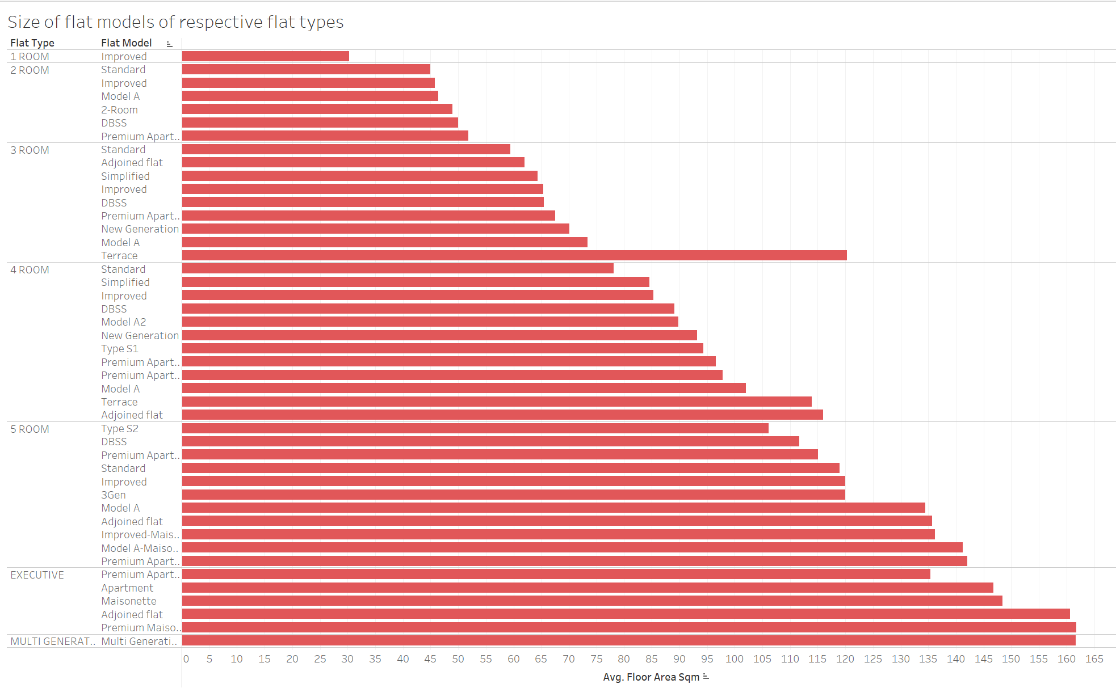

The user can see the comparison of the size of the flat models across the different flat types. The visual shows the increase in the size of the flat models across the flat types and gives a deeper understanding of the sizes of different flat models so that they can understand what flat models can satisfy their space needs. This visual helps answer the question of “What are the biggest-sized flat models in each flat type?”.

### 4.2.2 Average resale price of flat models

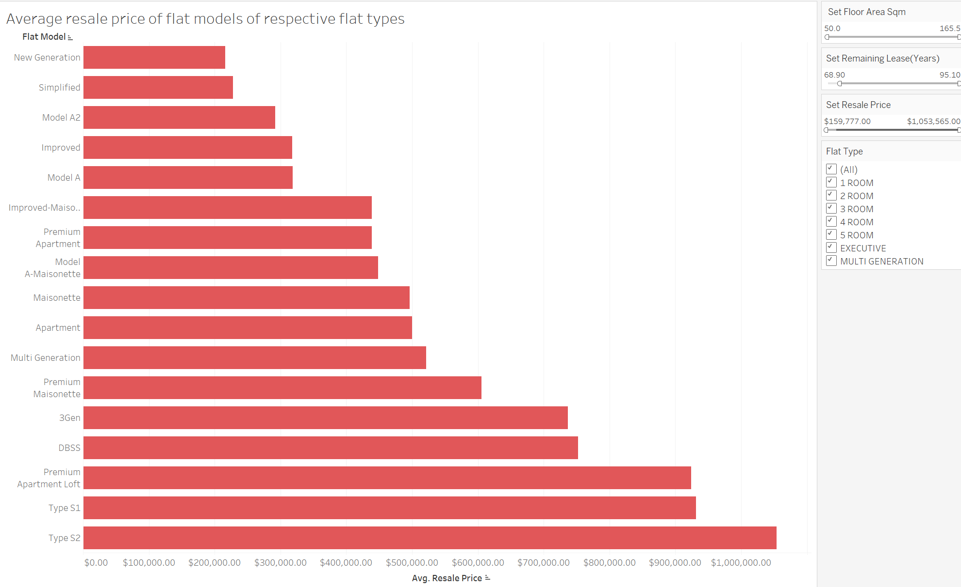

This visual shows the average resale price of the different flat models. Users can see the trends of the resale prices by the flat models. Users can also filter the visual according to their needs. They can set the range of the size of flat, remaining lease of the flat, the range of budget they have and they can choose the flat type they are interested in. This visual answers the question of “What are the average resale prices of the different flat models in each flat type?”.

### 4.2.3 Trends in average resale prices through the years

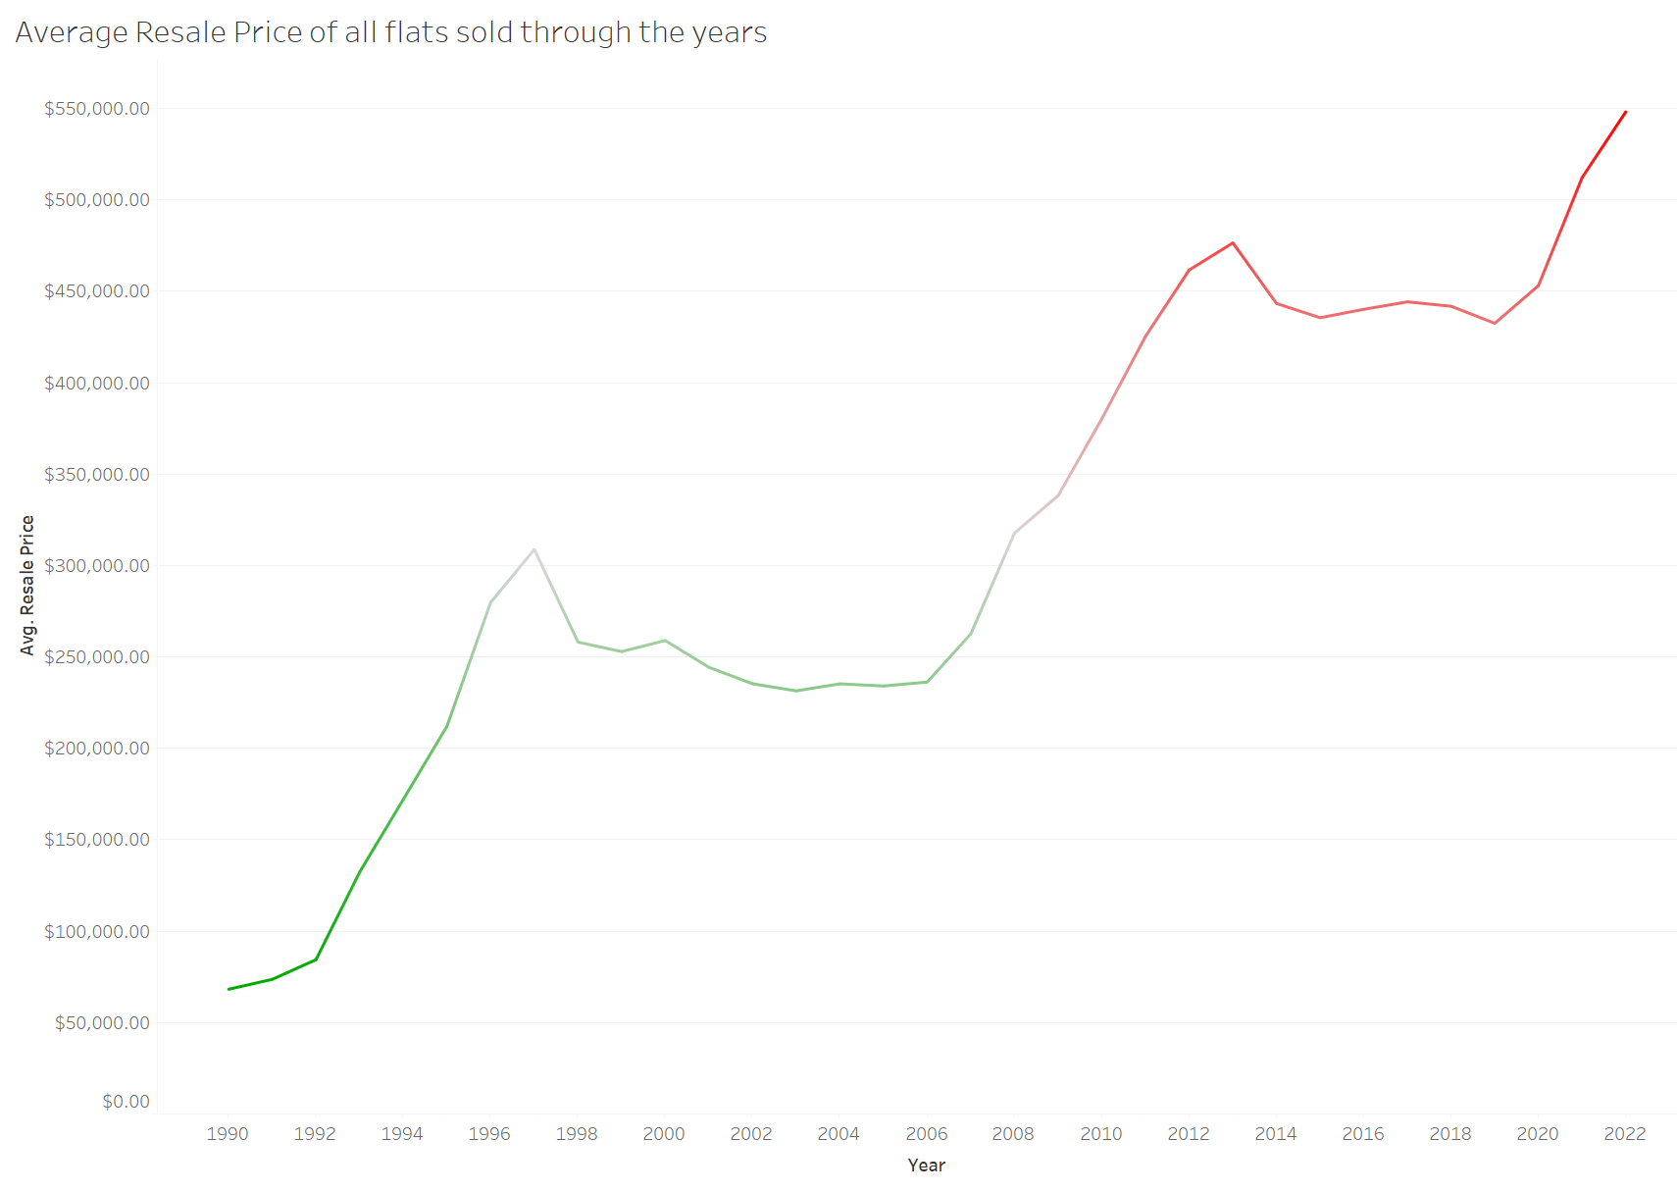

The line chart shows the patterns in the average resale prices of HDB flats in general through the years. From this, users can also predict the resale prices of HDB flats in the near future. The average resale prices of HDB flats have been increasing steadily for the past few years so it is safe to say that the prices will continue to increase in the future. This visual answers the question of “What are the changes in the average resale price across the different years?”.

### 4.2.4 Number of flats in budget

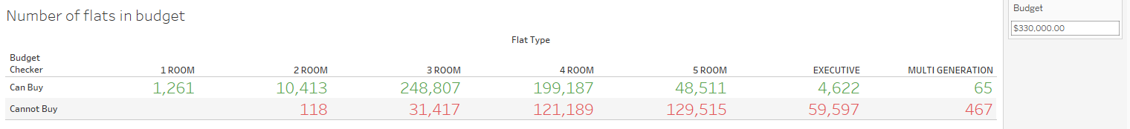

This visual shows a table that shows the number of flats for each flat type that is in the budget chosen. For this visual, I created a parameter for the budget value and a calculated field to differentiate the colour of the text. In the budget filter on the right, users can input their budget and the visual will change to show the number of flats that were in their budget for the respective flat types. With this visual, users will be able to see the number of houses they can afford for each flat type and make a decision for the flat type they would want to purchase. This visual answers the question of “How many flats of each flat type were in the budget?”.

### 4.2.5 Average price per square meter for flat models

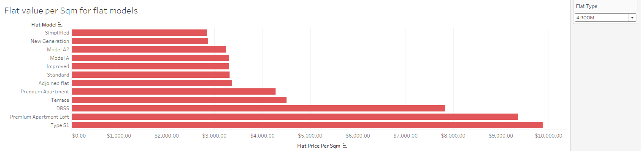

This bar chart shows the price per square meter of the different flat models that can be filtered by flat type using the single value dropdown filter at the right. Users will be able to see the flat models which are more value for money from this visual. I chose a single value dropdown filter as I wanted my users to just focus on the flat models for one flat type at a time. I made a calculated field in Tableau for price per square meter by dividing the average price and the average floor area square meter. This visual answers the question of “What is the price per square meter of the flat models of a flat type?”.

### 4.2.6 Proportion of number of flats sold in each region

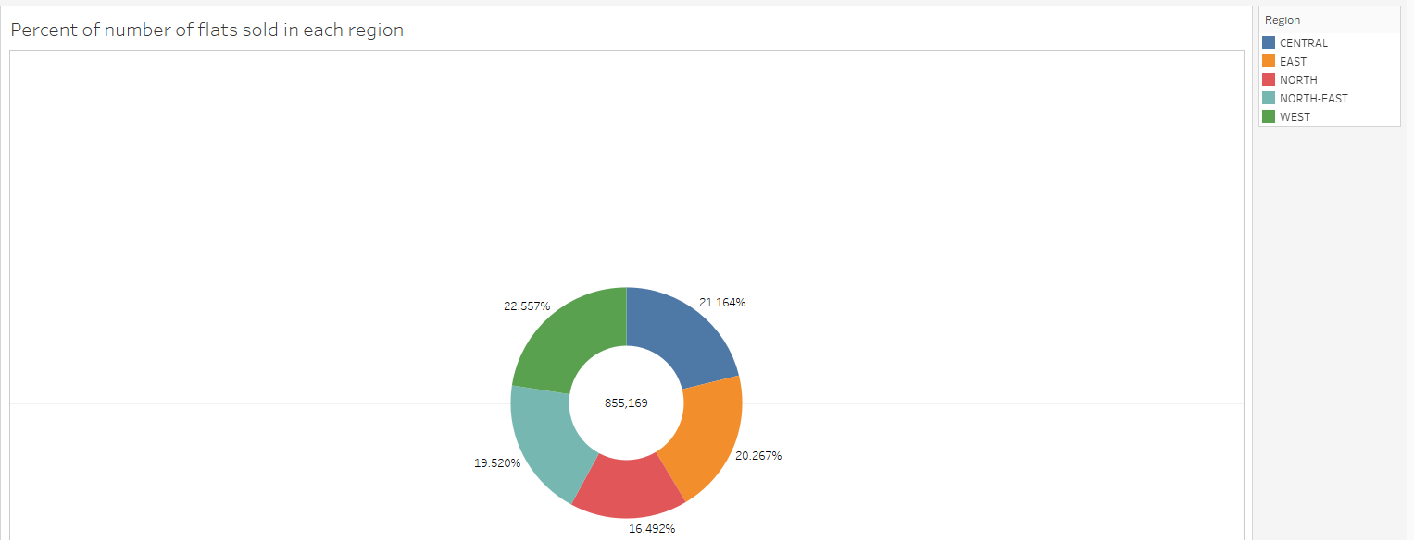

I made a donut chart to show the percentage of the number of flats sold in each region out of the total number of flats sold. The number of total flats is also in the middle. Users will be able to understand the popularity of the different regions as more flats sold would mostly mean a more popular region among buyers. The card on the right also shows which colour represents which region so users will be able to understand the chart from one glance. This visual answers the question of “What is the proportion of the number of flats sold in the different regions?”.

### 4.2.7 Average resale price of flats across different towns

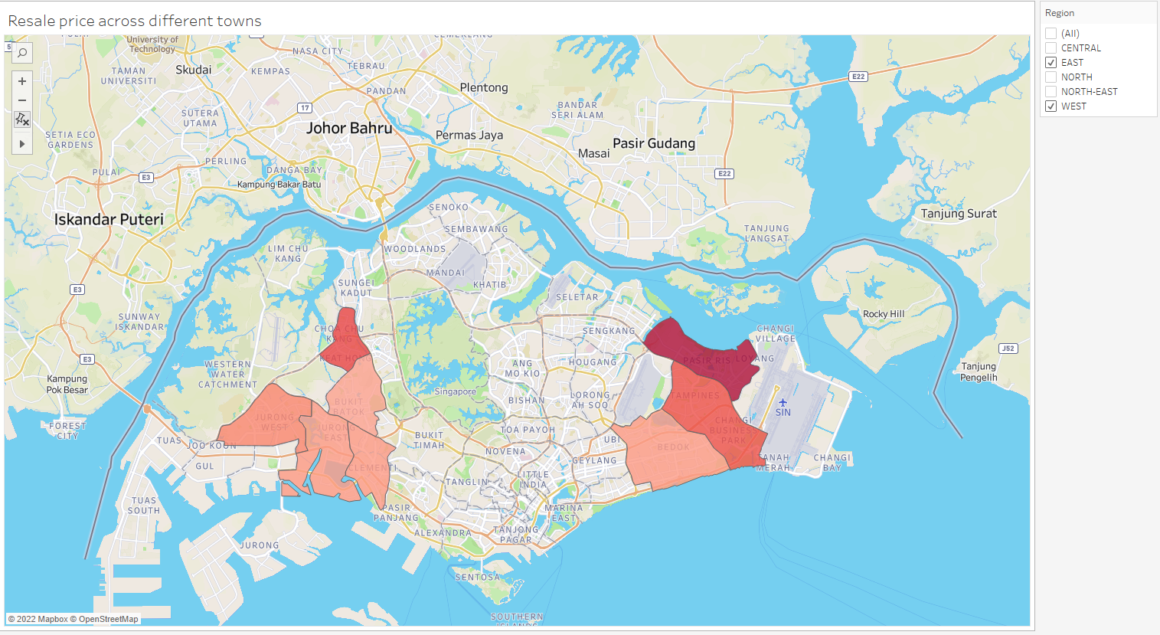

The filled map visual shows the average resale prices of flats across the different towns. The visual can be filtered by region. Right now, the visual is filtered by region which is why it is only showing the average resale prices of the flats in the towns at the East and West region. There is colour distinction between the average resale prices of the different towns to identify between the towns with the cheaper flats and more expensive flats on average. The darker the colour, the more expensive the town is. In the west region, Pasir Ris is the most expensive as seen from the red colour compared to Bedok which is peach colour. 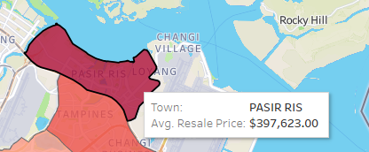

Average Resale price at Pasir Ris is about $397K.

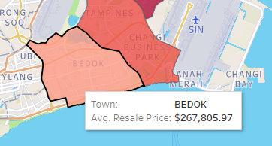

Average Resale price at Bedok is about $267K.

This visual helps answer the question of “What is the average resale price of the flats in the different towns?”.

### 4.2.8 Relationship between the story range and average resale price

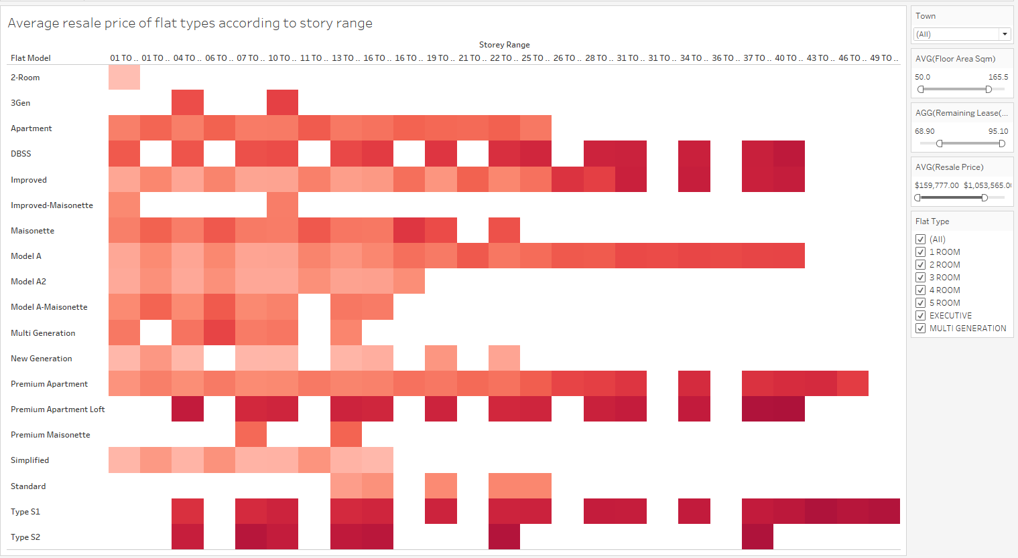

This treemap aims to show the relationship between the story range of the flats and the average resale price of the flat model. The average resale price is colour coded such that the greater the resale price is, the darker the colour is. From this, we can see that generally, the higher the story range is, the more expensive the flats are. There are also various filters to help make the visual more detailed. Users can choose a town, the range of the size of the flats they want to look at, the remaining lease of the flat and set a range for the average resale price the flats must fall in. They can also choose the flat type that they want to see the flat models for. All these filters cater to the user’s needs. This visual answers the question of “What effect does story range have on the average resale price of the flats?”.

### 4.2.9 Relationship between the average resale price and the size of the flat

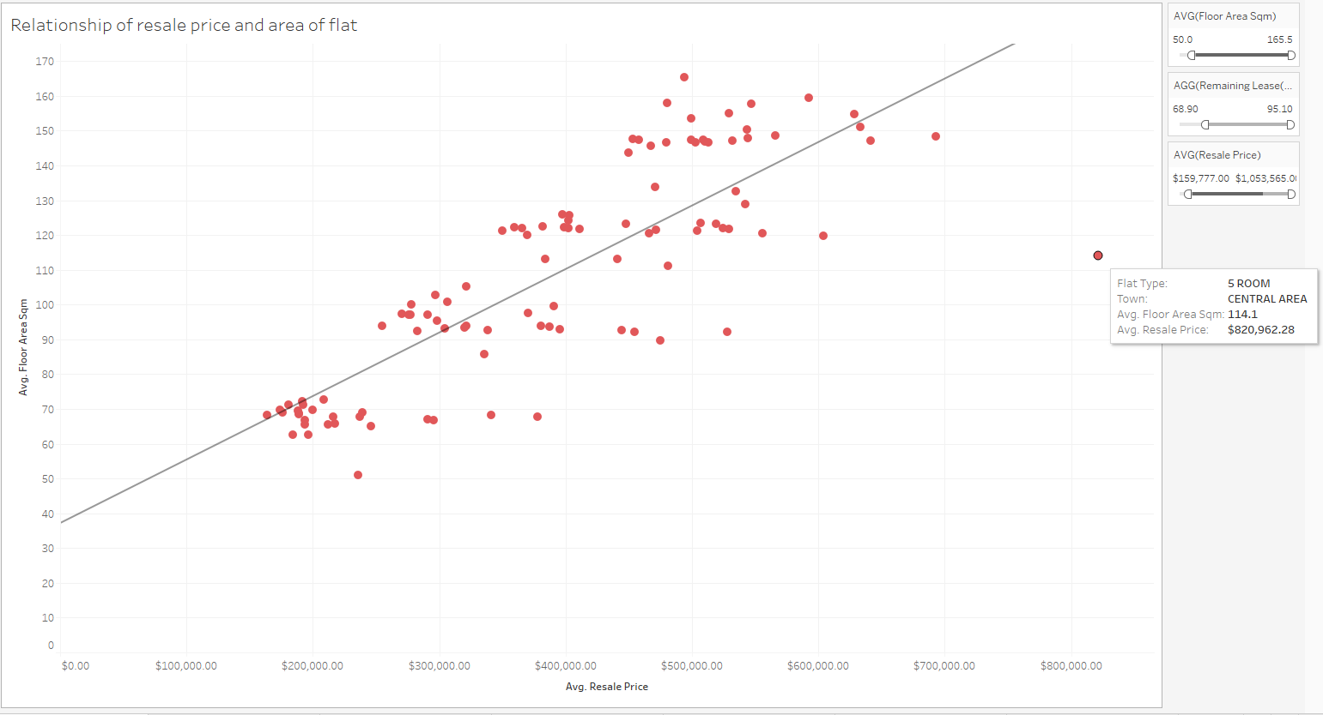

The scatterplot shows the trend between the size of the flat and the average resale price of the flat. As seen from the visual, as the size of the flat increases, the resale price of the flat also increases. However, there is an outlier and it is the mark that represents the sale of % room flats in the central region. On average, the 5 room flats in the central region were more expensive than other flats which were bigger in size. There are also several filters that allow users to choose the range for the size of the flat, the remaining lease in the flat and the resale price of the flat to have a more in depth view of the visual. This visual answers the question of “Does the size of the flat model affect the resale price of the flat?”.

### 4.2.10 Percentage of number of flats sold for each flat type across different regions

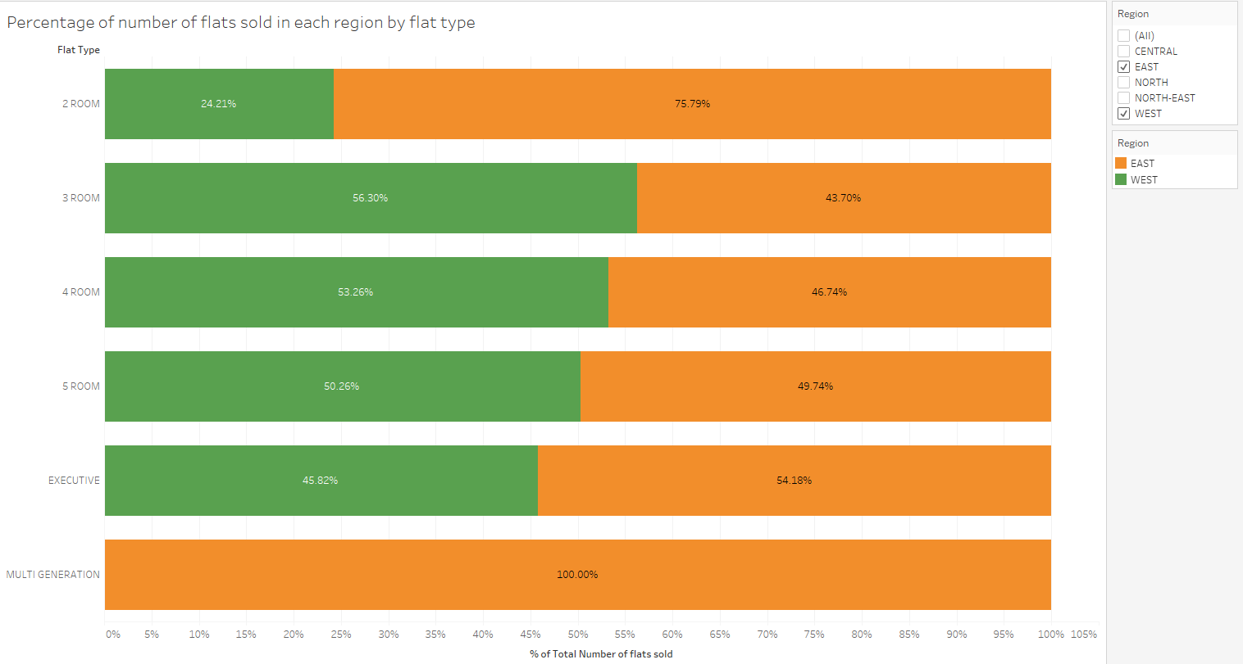

The stacked bar chart shows the percentage of the number of flats sold for each flat type for each region. This will allow users to understand the popularity of the different flat types across the different regions. The filter allows users to choose the regions that they are interested in. This visual answers the question of “What is the popularity of the different regions for the different flat types?”.

### 4.2.11 Distribution of flat prices of flat types in towns

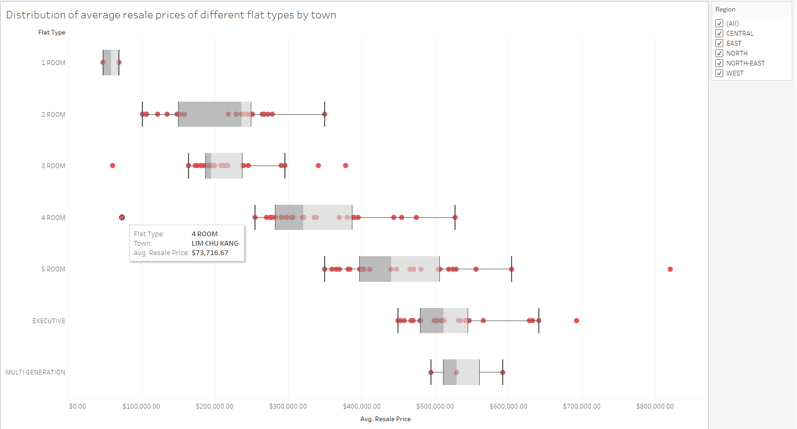

The box plot shows the distribution of the average resale prices of the different flat types in the different towns that has the flat type. From this visual, we will be able to identify whether the prices of the flat types in the towns in below average or above average. We can also identify outliers in the box plot. For example, the 4 room flats in Lim Chu Kang are extremely cheap compared to the 4 room flats in the other towns. Users can also filter the visual by region if they only want to look at the distribution of the flat prices for certain towns in a certain region. This visual answers the question of “What is the distribution of the resale prices of the houses of a flat type across different towns?”.

### 4.2.12 Number of flats sold in each street of a town

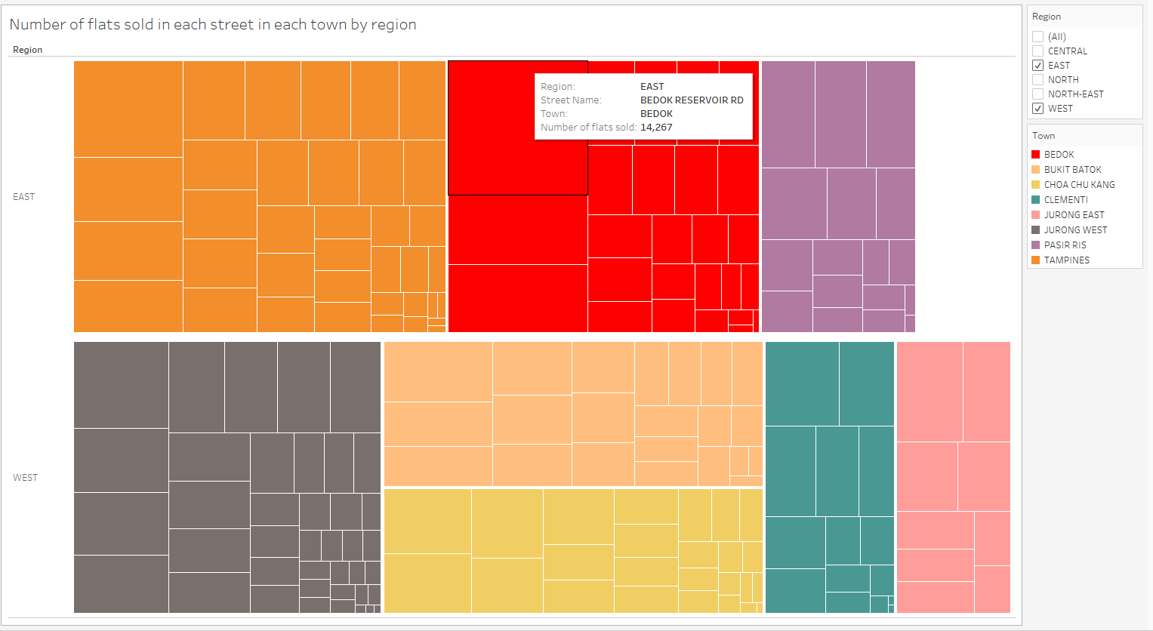

The heat map shows the number of flats sold in each street in a town. The different towns are coloured differently and each square represents a street in the town. The bigger the box, the greater the number of flats sold in that particular street. This will help users determine which streets in each town is the more popular ones among buyers. As seen above the bigger square for the Bedok town represents Bedok Reservoir Road as the number of flats sold there is the greatest and hence, it is the most popular street to buy a house among buyers in Bedok. This visual helps answer the question of “What is the number of flats sold in each block in each street and in each individual town?”.

### 4.2.13 Average price of flat types in the streets of a town

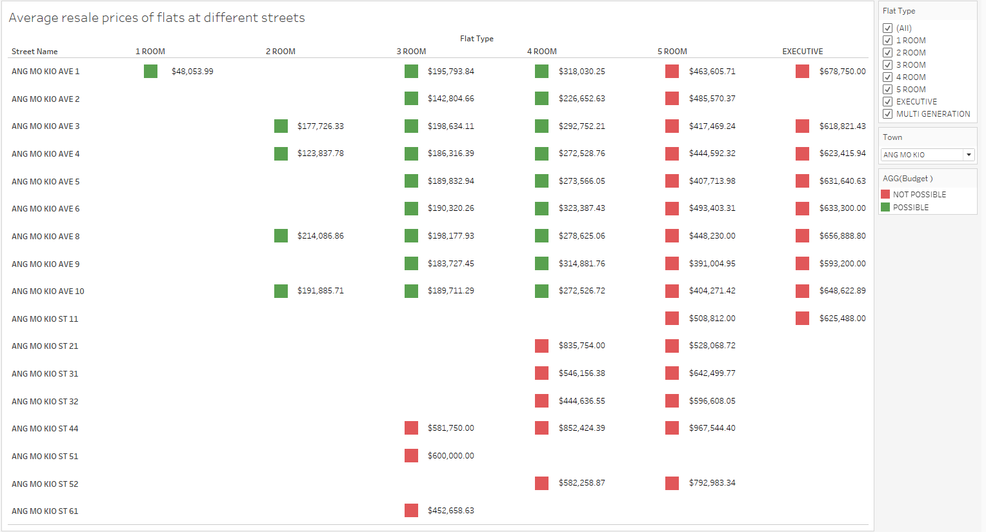

The table above shows the average price of the different flat types in the streets of a town. There is also an indicator to signify if the average price of the flat type in the street is in the budget of $330,000. Green indicates that the average resale price is under the budget while red indicates otherwise. Users can make a choice on the streets that they are interested in by looking at the resale prices of the flats in the different streets of a town. Users can also filter the visual to show the flat types they are interested in and the town that they are interested in. The question that this visual answers is “What are the average resale prices of flats in different streets across the different towns?”.

### 4.2.14 Number of bus stops in each town

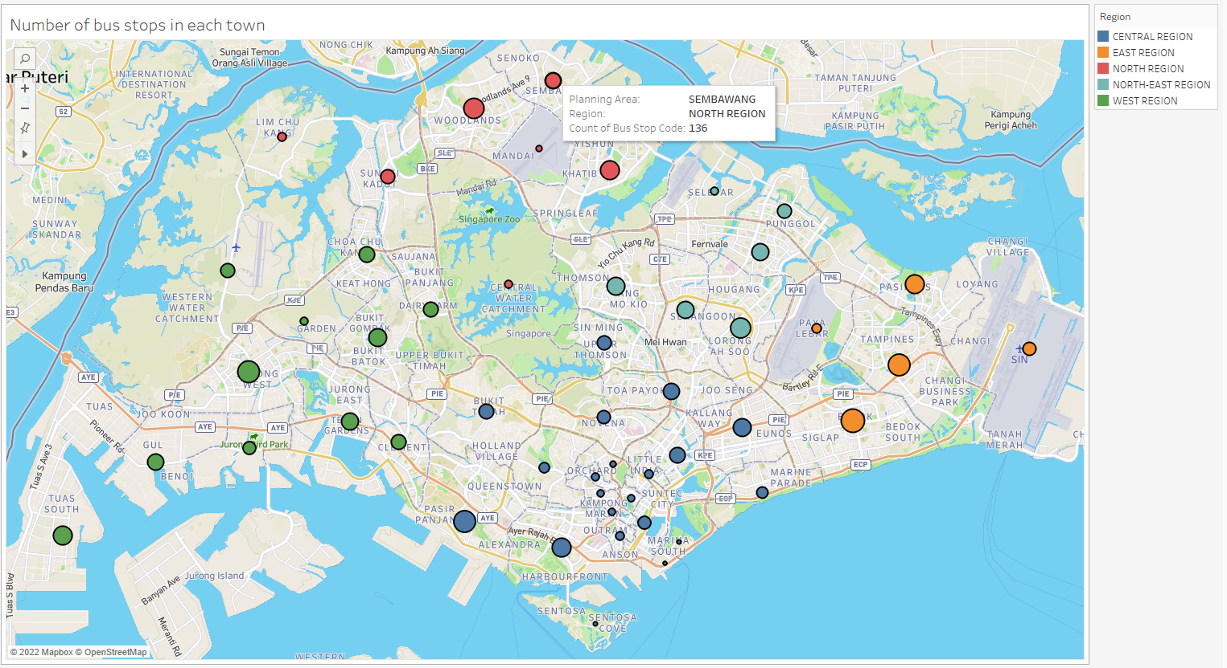

The symbol map shows the number of bus stops there are in each region. Each mark represents a town and the greater the number of bus stops in the town, the bigger the mark size. The different marks are also colour coded based on region. If users want to see the specific number of bus stops in a town, they can hover over the mark for that town as shown above in the picture.

### 4.2.15 Changes in number of flats sold for each flat type through the years

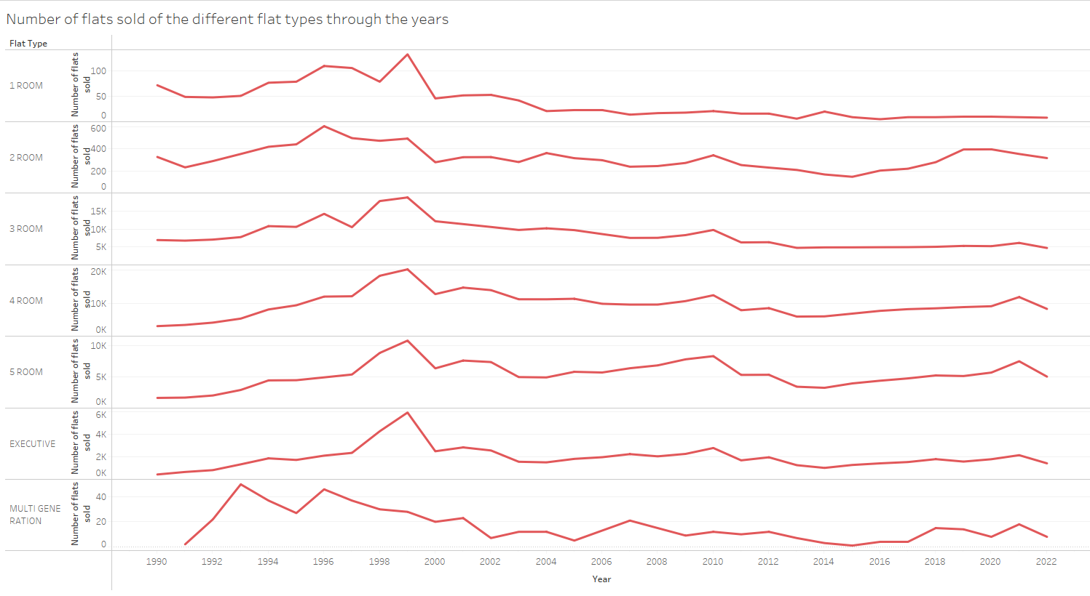

The sparklines show the changes in the number of flats sold for each flat type through the years. The axis for the number of flats sold is independent on the number of flats sold because if all the axis were the same, some of the lines will be flat and we will not see any patterns in the line. Users can see the trends in the popularity of the flat type they are interested in and they can also predict the number of flats sold for the flat types in the future. This visual answers the question of “How does the number of flats sold of different flat types change over the years?”.

### 4.2.16 Relationship between remaining lease and average resale price

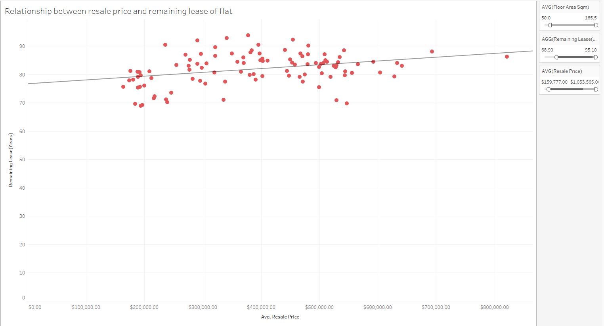

From the scatterplot, we can see that as the remaining lease is greater, the average price increases too. There are various filters available where users can set the range of values for size, remaining lease and average price that they are interested in. The scatterplot answers the question of “Does remaining lease affect the resale price of the flat?”.

### 4.2.17 Distance of each town from SGH

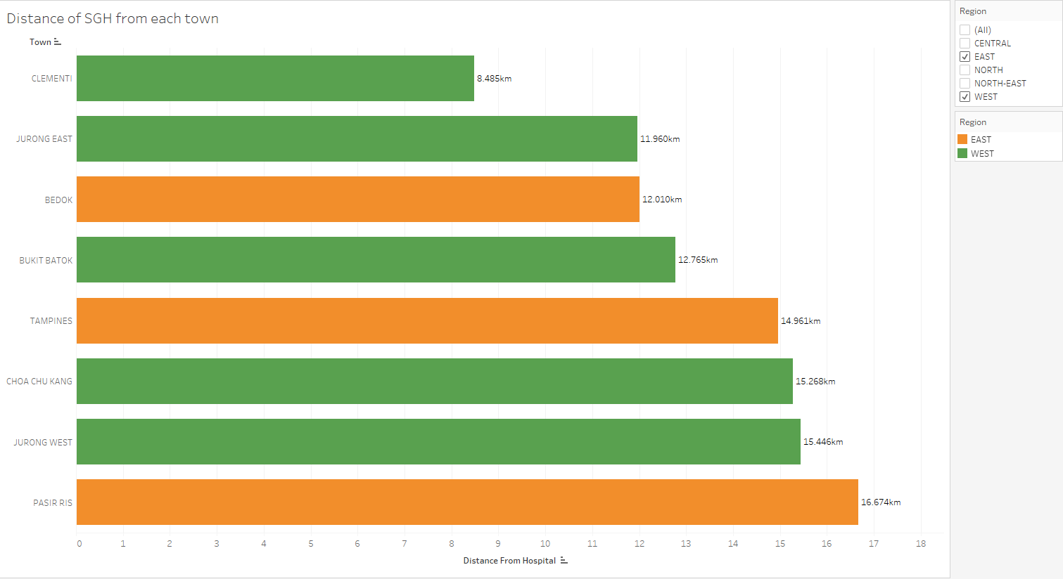

The bar chart shows the distance between the towns and SGH. The greater the distance, the longer the bar. The visual can also be filtered by the region to compare the distance of the towns from SGH across different regions. Since my user works at SGH, the smaller the distance, the better as he would not need to spend too much time travelling. This bar chart answers the question of “What are the towns that are closest to SGH?”.

### 4.3 Dashboards and Data Story

### 4.3.1 General Information Dashboard

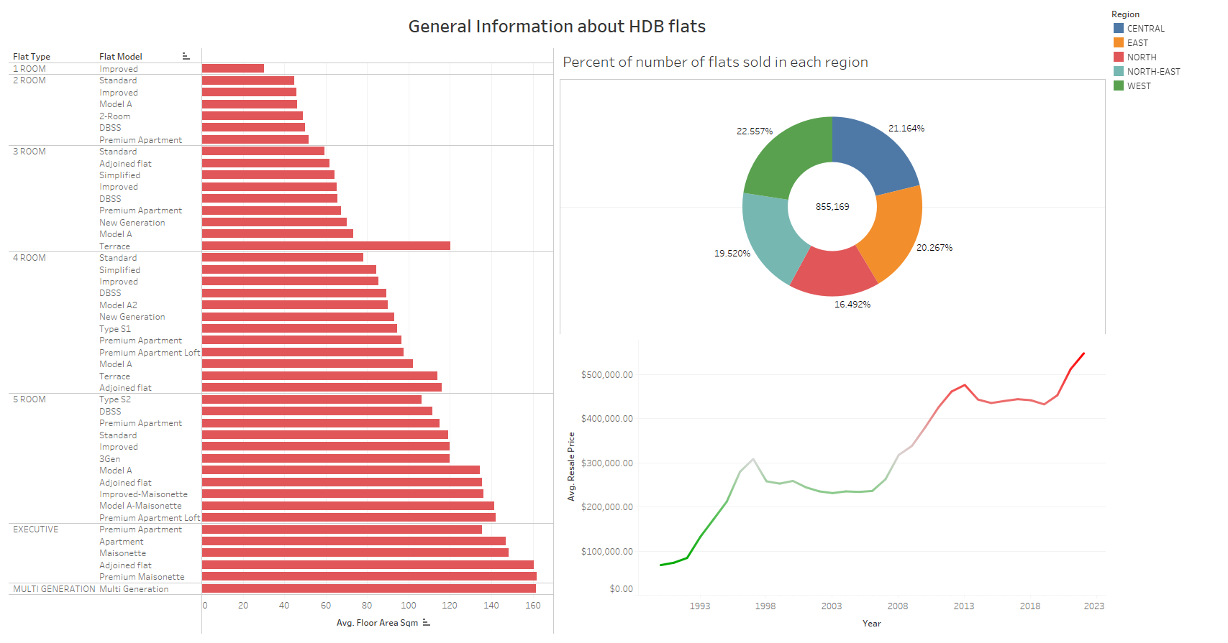

This is an informative dashboard that shows some general information about HDB flats. On the left, the bar chart visual shows the size of the different flat models in each of the flat types. You will be able to get an idea of the sizes of the different flat models of each flat type from this visual. The donut chart shows the percentage of the number of flats sold in each region. There is also a card on the right to aid the understanding of the visual which shows the color that represents each region. The visual shows brief information about the popularity of each region. The most popular region to buy flats in is the West. Next, the line chart shows the changes in average price of all the HDB flats sold throughout the years. In the past few years, the average prices of HDB flats have been increasing and it is predictable that the prices will continue to increase so it is a good time to buy a HDB flat now.

### 4.3.2 Factors of flats affecting resale price

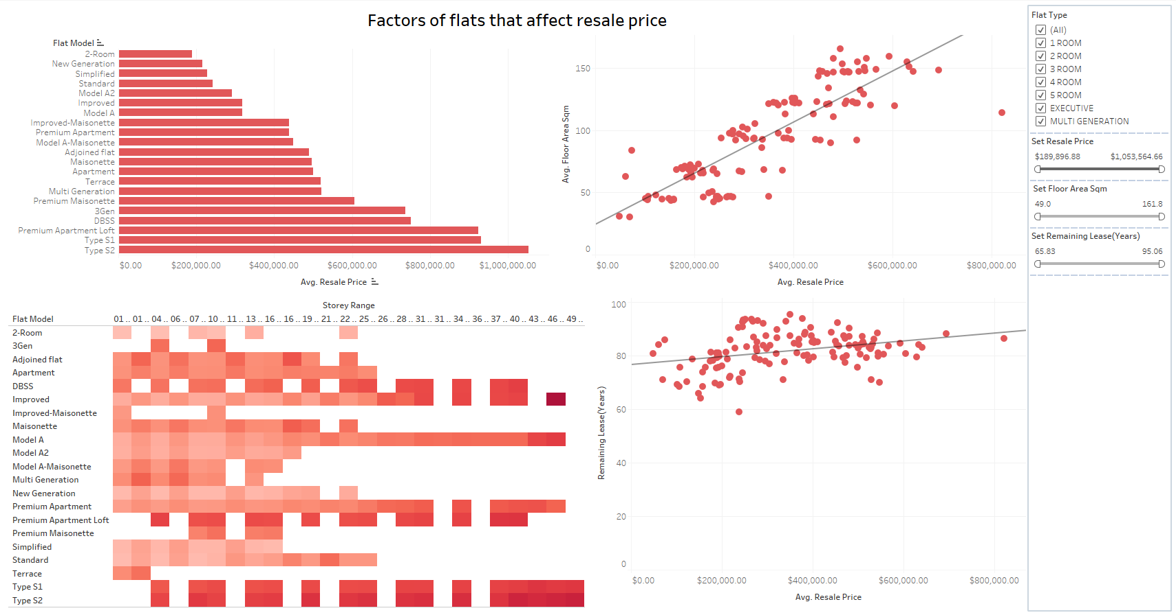

This is an exploratory dashboard that shows the factors of flats that affect the resale prices of flats. I decided to show you the factors that affect the price as budget is a very big concern for you. There is a bar chart showing the average price of the different flat models, the scatterplot on the top right shows the relationship between the size of the flat and resale price, the tree map shows the relationship between the story range and resale price and the scatterplot on the bottom right shows the relationship between the resale price. For the tree map, the darker color represents higher resale price so generally the flats in higher story ranges is more expensive.

If you are interested in a flat type, you can choose the flat type you are interested in using the filter. You can also set the price range, size range and remaining lease range of the flat you are interested in.

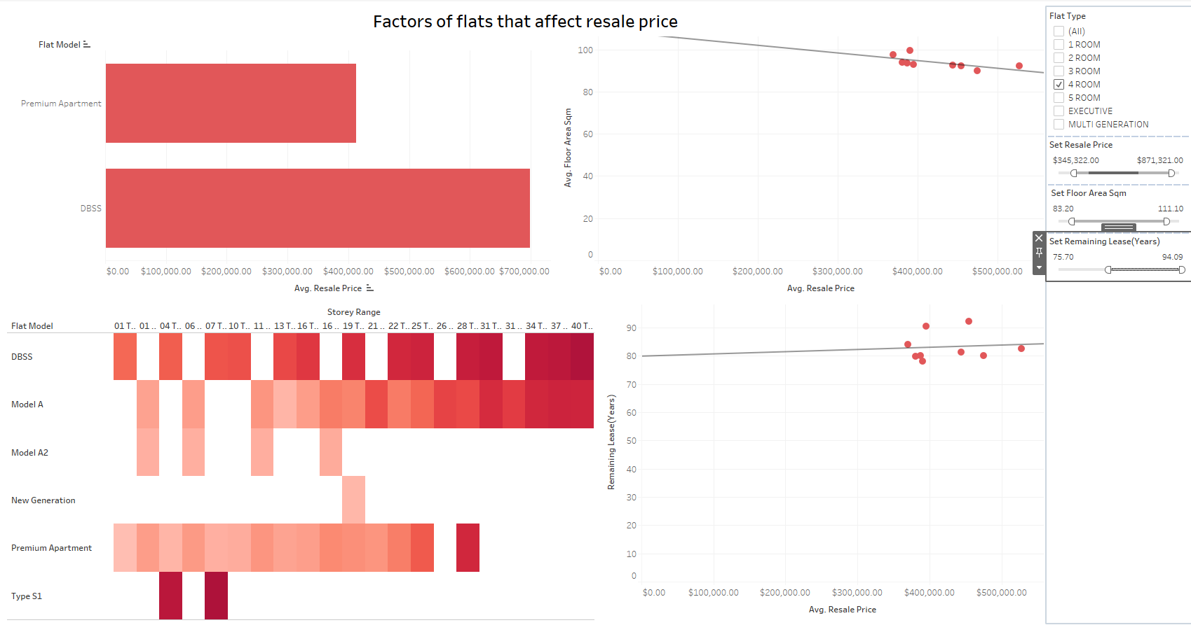

I have selected 4 room flat in this example and have also changed the range of the values for remaining lease, average size of flat and average resale price of the flat. Now all the visuals will only show information about 4 room flats only in the ranges of the values chosen for remaining lease, average flat size and average resale price. U can also see that the trend line for the scatterplot for the relationship between average size and average price on the top right has changed. Instead now, the scatterplot shows that the smaller sized flats are more expensive than the bigger sized flats which is an interesting trend.

### 4.3.3 Comparison between regions

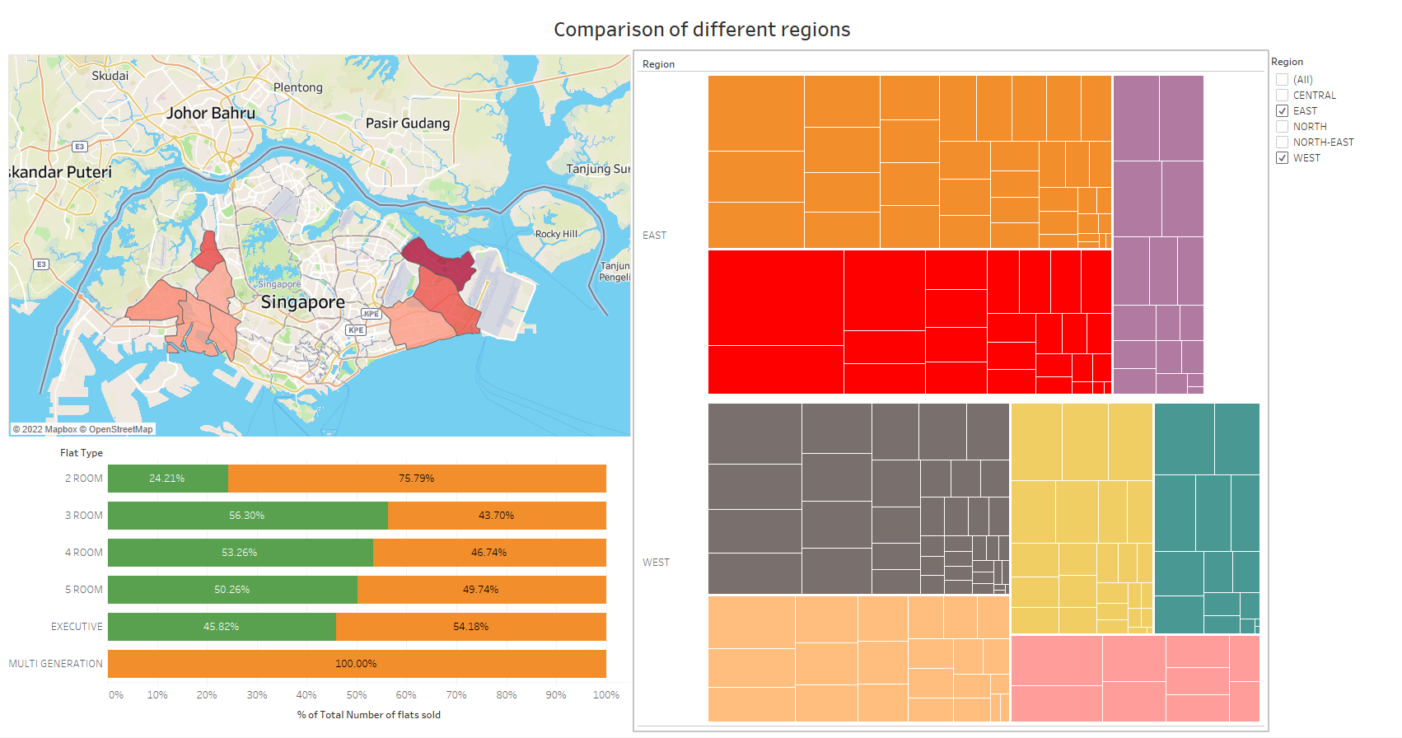

This dashboard allows for comparison between different regions. The map visual on the top left shows the average resale price across the different towns. The darker the colour the more expensive the average resale price. The 100% stacked bar chart shows the percentage of the number of flats sold for each flat type and the heat map shows the number of flats sold in each of the streets of the different towns. Right now all the visuals are showing the information for East and West as I wanted to compare the two regions.

For greater details, we can filter further by for example clicking on a flat type if we want to see the information for only that particular flat type instead of the flats.

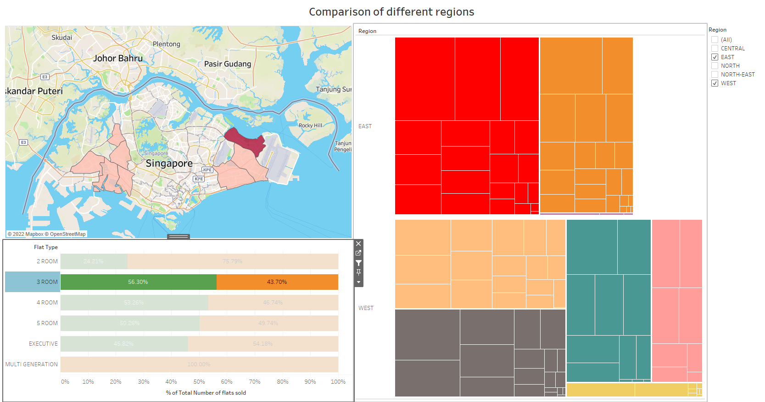

If I select 3 room, all the visuals will only show me the Information for 3 room flats.

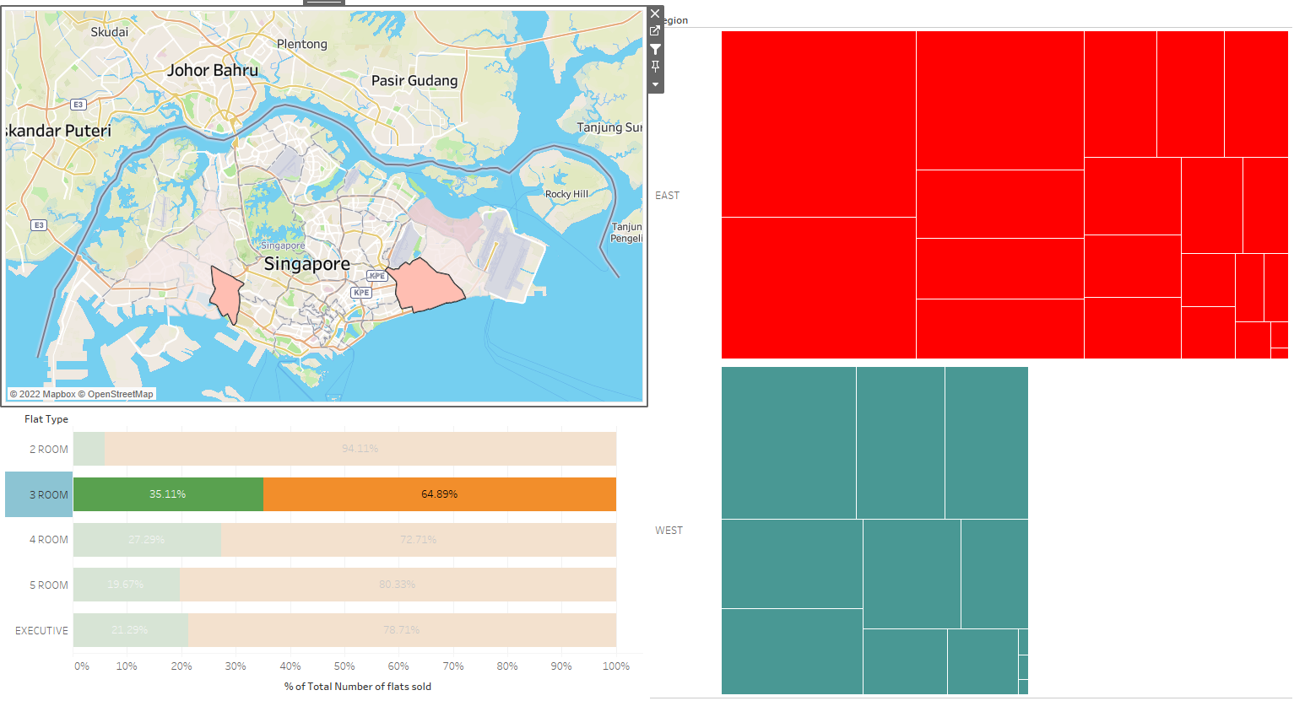

I can also go into further detail by comparing the different towns of 2 different regions. Now, the stacked bar chart shows the comparison for the 2 towns I selected and the heat map only shows the information for the streets in the 2 towns I selected.

### 4.3.4 Data Story

In the data story, I will be recommending the flats my stakeholder can look at to buy.

1) Flat types in budget

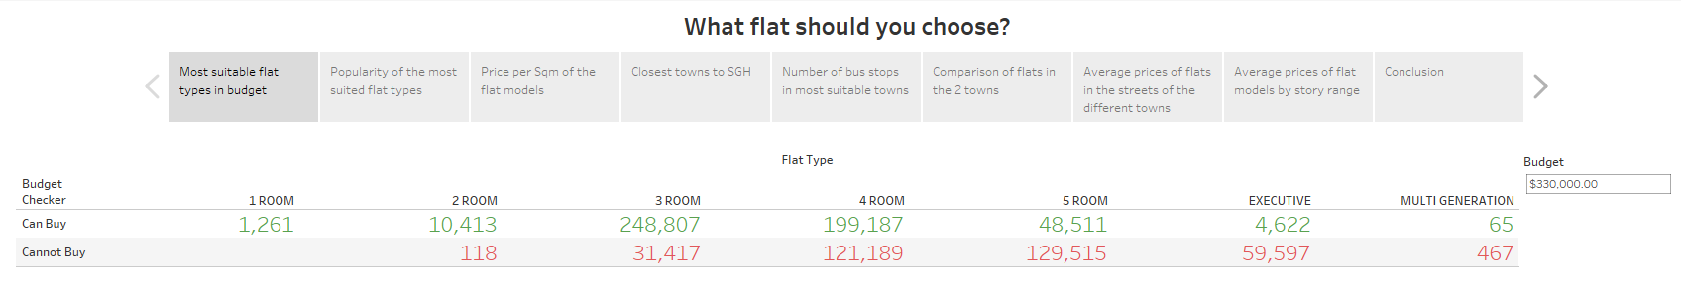

Firstly, for the budget of 330000, the 2 most available flat types is 3 room and 4 room but I would recommend the 4 room as my stakeholder will be having more children later on and my stakeholder would need the extra space.

2) Popularity of the most suitable flat types

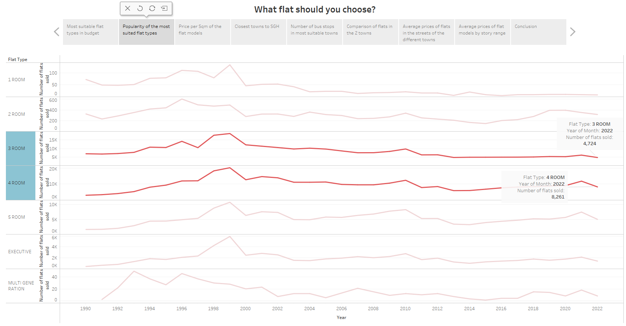

We can see that 4 room flat types are the most popular flat type. Comparing it with the other flat types, it has been selling the most in the recent years.

3) Most value for price flat models

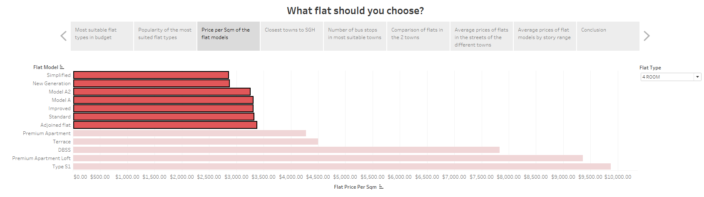

Under the 4 Room flat type, the 7 most value for money flats are the ones that I have highlighted. So it would be best to consider purchasing these 7 flat models.

4) Towns closest to SGH

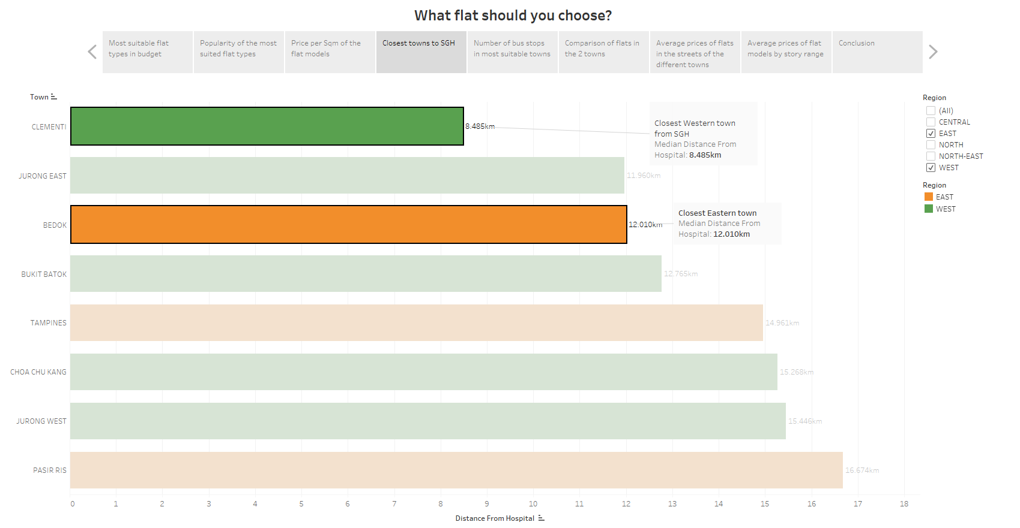

Since my stakeholder is unsure of buying a house in the Eastern region or the western region, I will help my stakeholder. In the Eastern region, the closest town to SGH is Bedok at a distance of around 12km and for the western region, the closest town to SGH is clementi at a distance of around 8.5km. These are the 2 most suitable towns.

5) Number of bus stops in each town

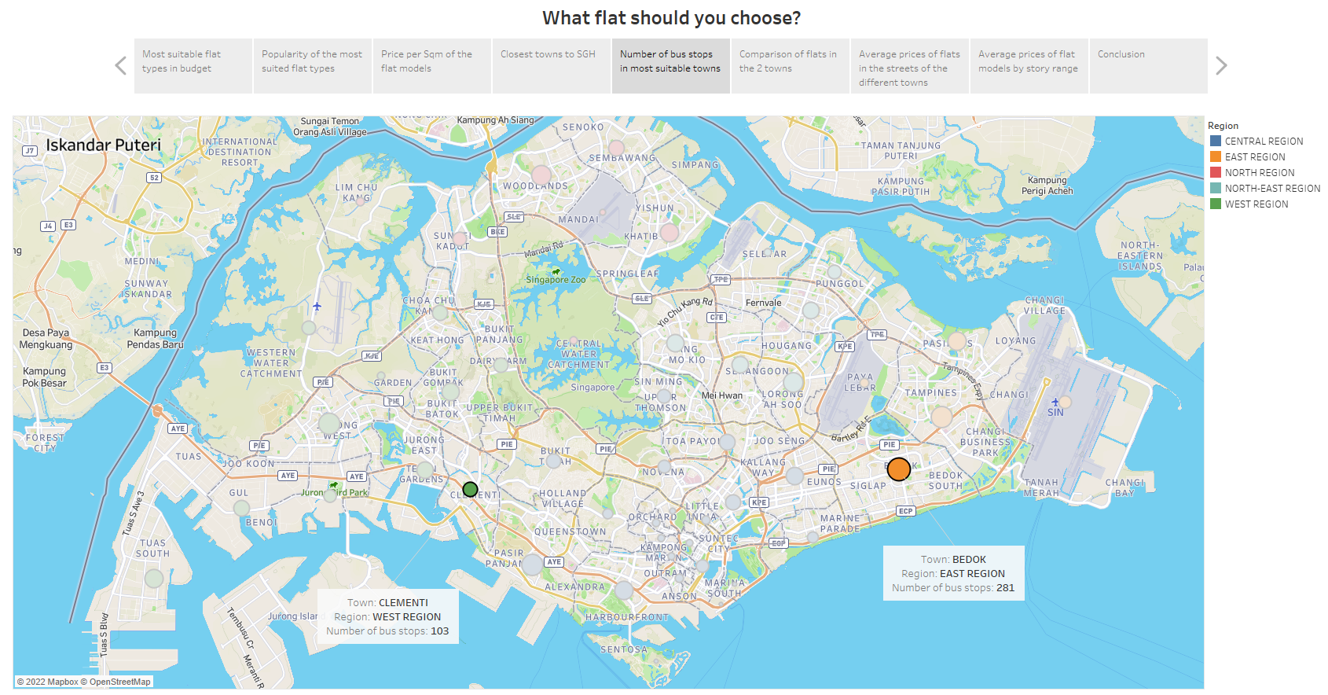

However, since the main mode of transportation is buses, the number of bus stops in the town is very important. In clement, there are 103 bus stops while Bedok has 281 bus stops. This can also mean that more buses go through Bedok than clementi.

6) Recommended town

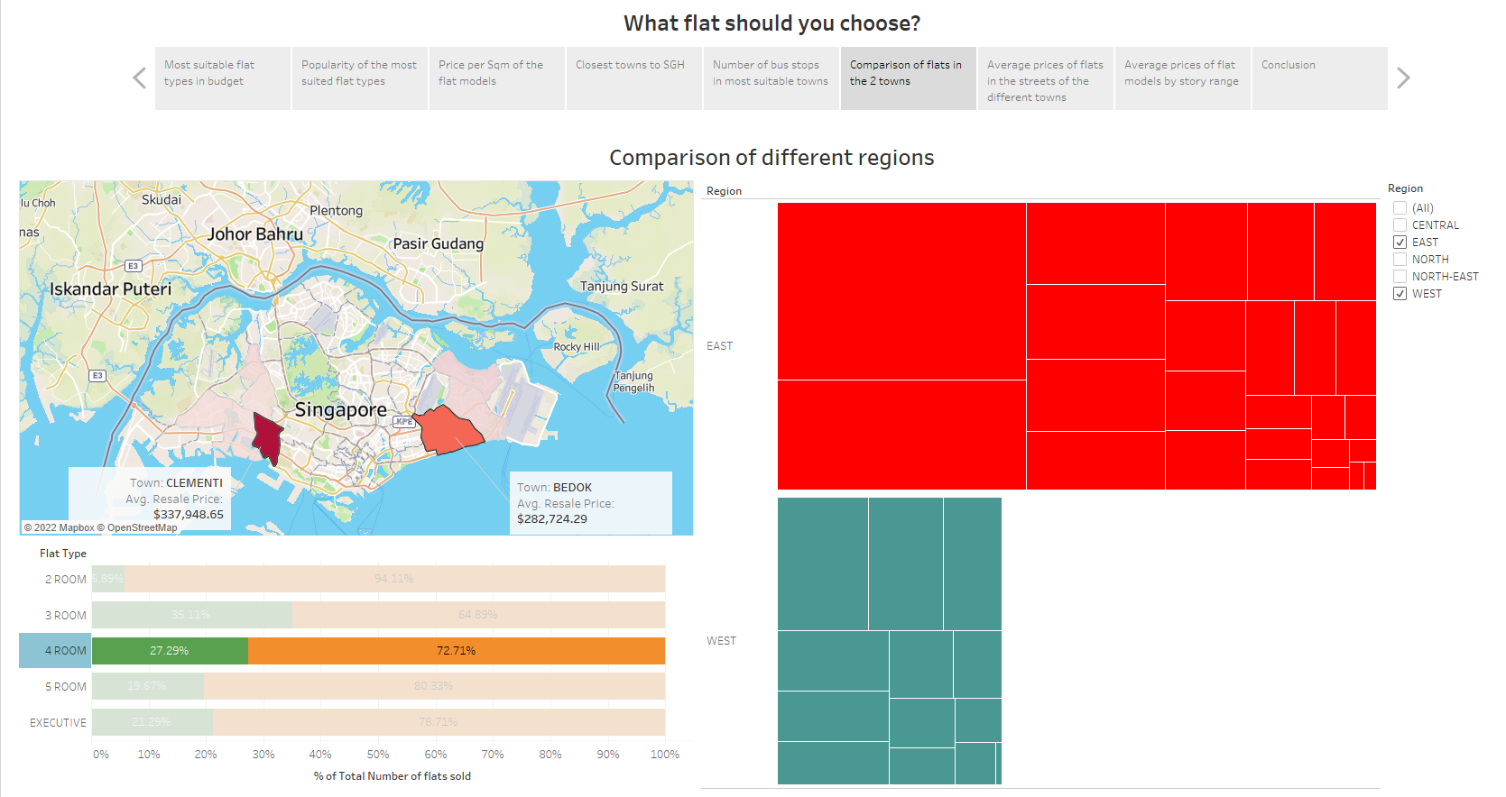

Now, if we look at only 4 -Room flats in Bedok and Clementi, the average resale price of the 4-room flats in Bedok is less than that in Clementi. There are also more flats sold in Bedok compared to clementi. Hence, Bedok will be a cheaper area to buy 4-room flats in and we can also see Bedok is more popular than Clementi among buyers for 4 Room. Hence, the town I recommend is Bedok.

7) Average prices of flats in the streets of the different towns

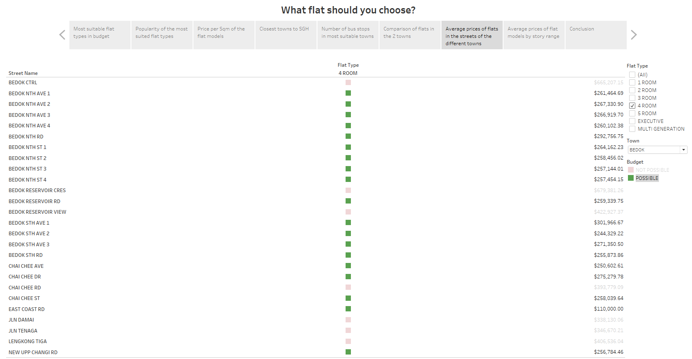

Now if we look at the number of streets that my stakeholder can buy in for Bedok, we can see that my stakeholder can purchase a house in most of the streets in Bedok as they fall in the budget.

8) Average prices of flat models by story range

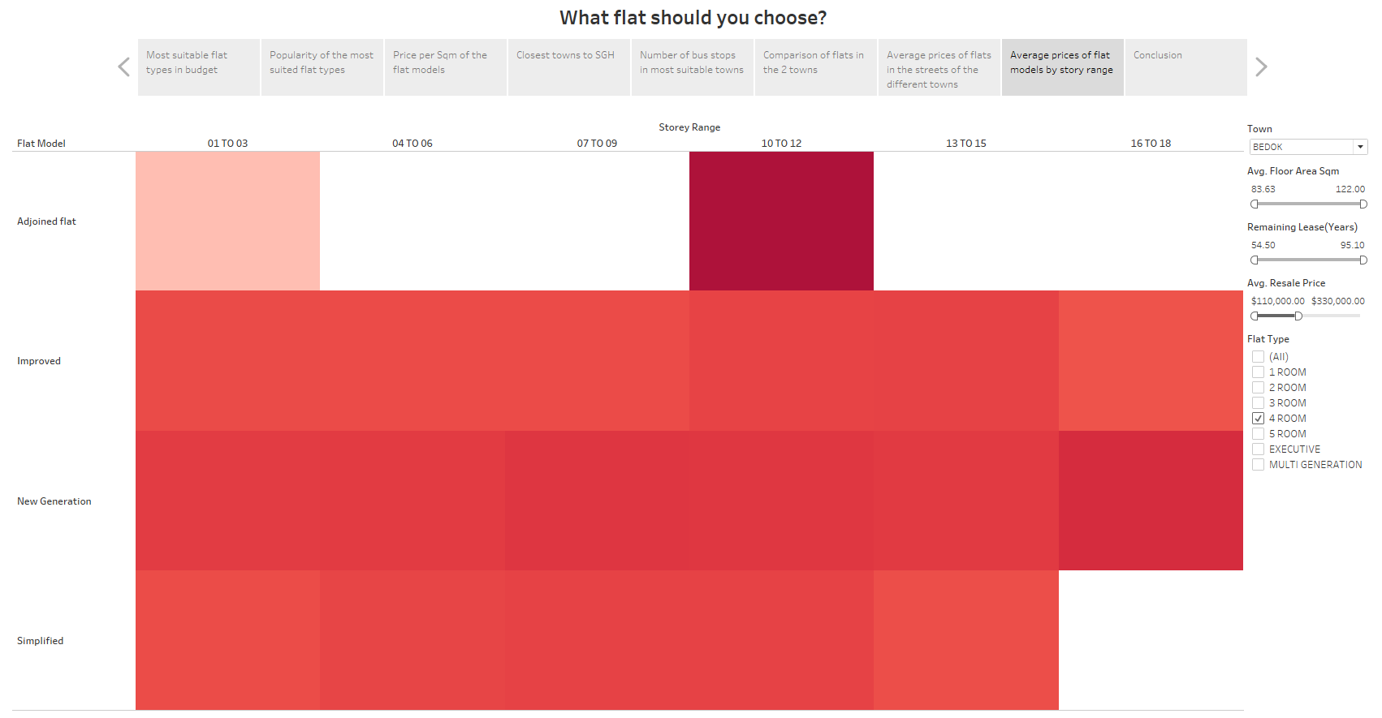

Next, for the four room flats in your budget in Bedok, the story ranges that you can look at buying a house in is from the first floor to the 18 floor.

9) Conclusion

